**TreasurePot**

# Menu

## Soup Base

**Spicy soup**（A soup made from traditional Sichuan spices and chili, spicy taste）

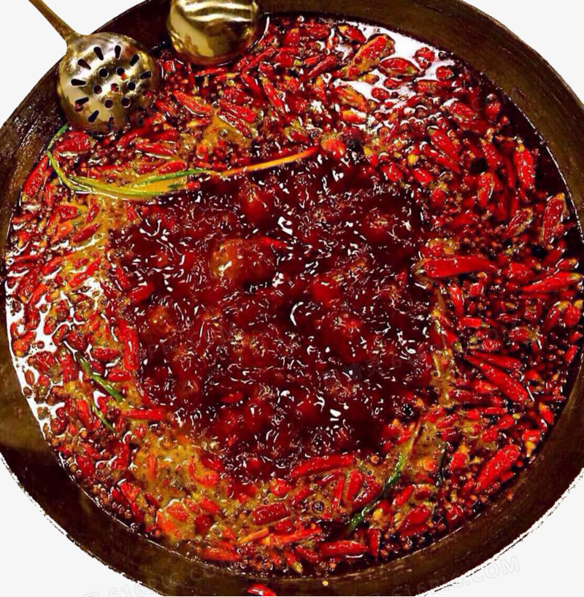

Reference：<http://616pic.com/sucai/1xrid3jm1.html>

(*麻辣重庆火锅图片免费下载_PNG素材_编号1xrid3jm1_图精灵*, n.d.)

ID: KjSUc9

**Tomato soup** (A soup made from fresh tomatoes, sweet and sour taste.)

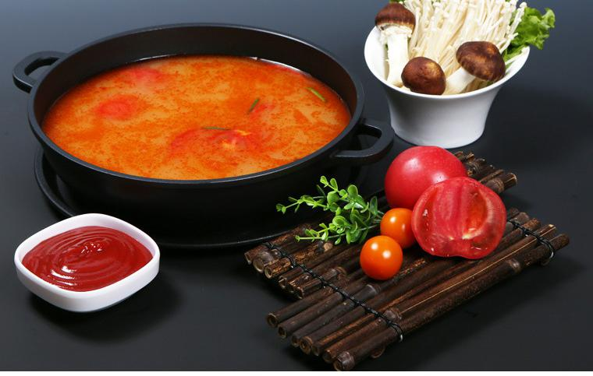

Reference:

<https://image.baidu.com/search/detail?ct=503316480&z=0&ipn=d&word=%E7%95%AA%E8%8C%84%E6%B1%A4%E5%BA%95%E5%9B%BE%E7%89%87&step_word=&hs=0&pn=0&spn=0&di=127710&pi=0&rn=1&tn=baiduimagedetail&is=0%2C0&istype=0&ie=utf-8&oe=utf-8&in=&cl=2&lm=-1&st=undefined&cs=3300607653%2C4073655397&os=3069888121%2C840547364&simid=42096681%2C587812203&adpicid=0&lpn=0&ln=1258&fr=&fmq=1634937232400_R&fm=&ic=undefined&s=undefined&hd=undefined&latest=undefined&copyright=undefined&se=&sme=&tab=0&width=undefined&height=undefined&face=undefined&ist=&jit=&cg=&bdtype=0&oriquery=&objurl=https%3A%2F%2Fgimg2.baidu.com%2Fimage_search%2Fsrc%3Dhttp%3A%2F%2Fimg001.hc360.cn%2Fm6%2FM01%2FC3%2F79%2FwKhQolc0QRuEfIt4AAAAAKhMYp4584.jpg%26refer%3Dhttp%3A%2F%2Fimg001.hc360.cn%26app%3D2002%26size%3Df9999%2C10000%26q%3Da80%26n%3D0%26g%3D0n%26fmt%3Djpeg%3Fsec%3D1637529241%26t%3D1fa1ac9cddc625b055d0d9dd131f74ab&fromurl=ippr_z2C%24qAzdH3FAzdH3Fkdk_z%26e3Bivnma_z%26e3Bv54AzdH3Ff7rrsyfjsuAzdH3Fcc08bl8m9_z%26e3Bip4s&gsm=1&rpstart=0&rpnum=0&islist=&querylist=&nojc=undefined&dyTabStr=MCwzLDYsMiw0LDEsNSw3LDgsOQ%3D%3D>

(番茄汤底图片的搜索结果_百度图片搜索, n.d.)

ID:Su3jO4

**Pork bone soup** (A soup made from pork bone, mellow taste.)

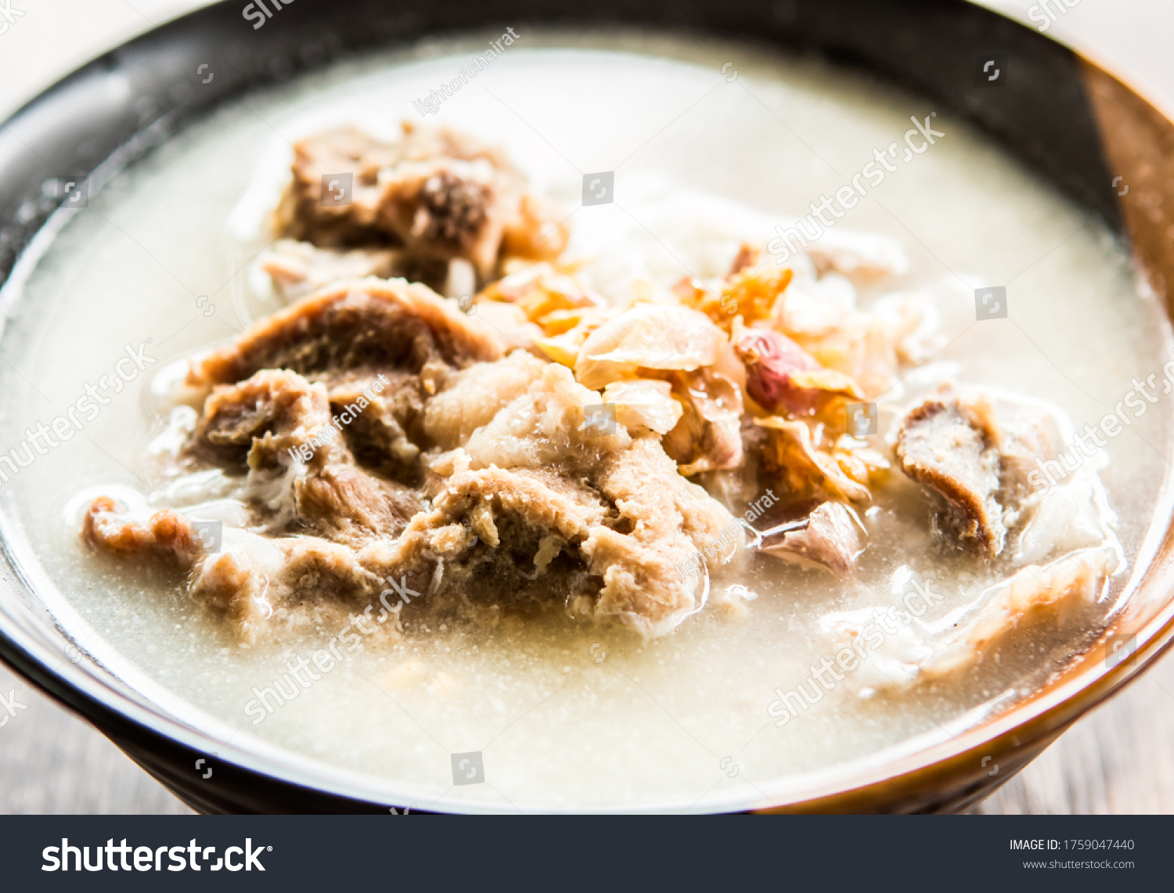

Collection date:2021/10/22 , Collector: Shixi Wu

Reference:<https://www.shutterstock.com/zh/image-photo/pork-bone-boiled-rice-bowl-out-1759047440>

(*Pork Bone Boiled Rice Bowl Out 库存照片（立即编辑）1759047440*, n.d.)

ID:FvbgoI

**Bacteria soup** (A soup made from various fresh mushrooms, light and refreshing taste.)

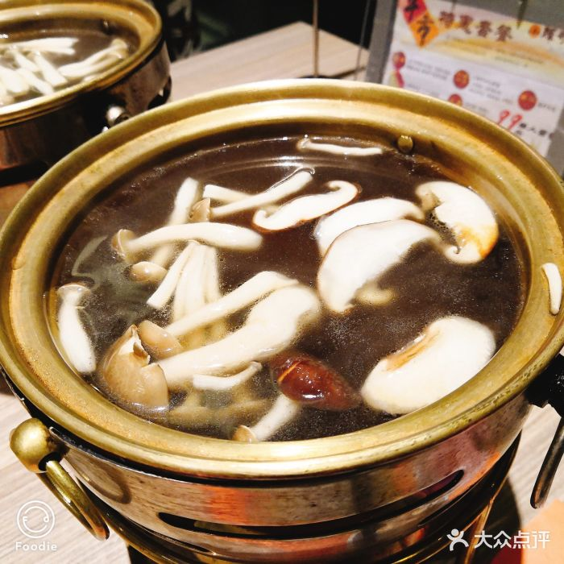

Collection date:2021/10/22 , Collector: Shixi Wu

References:

<http://qcloud.dpfile.com/pc/0fazTSXBltE8NS2E8FC1zSK7XzYmz2NOFFE7kE-4_Vt8ho6p7_gxi8ZVgPTI1Cd2joJrvItByyS4HHaWdXyO_DrXIaWutJls2xCVbatkhjUNNiIYVnHvzugZCuBITtvjski7YaLlHpkrQUr5euoQrg.jpg>

(*0fazTSXBltE8NS2E8FC1zSK7XzYmz2NOFFE7kE-4_Vt8ho6p7_gxi8ZVgPTI1Cd2joJrvItByyS4HHaWdXyO_DrXIaWutJls2xCVbatkhjUNNiIYVnHvzugZCuBITtvjski7YaLlHpkrQUr5euoQrg.Jpg (700×700)*, n.d.)

ID:8L3UyL

## Meats

**Lamb roll** (Lamb rolls are made from fresh lamb.)

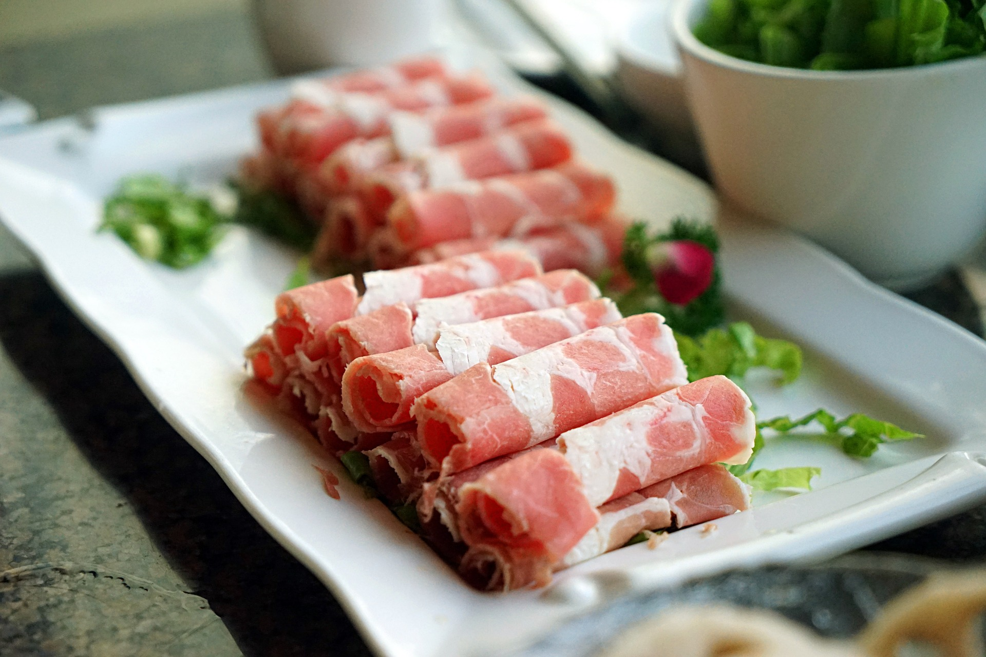

Reference:

<https://pixabay.com/zh/photos/meat-lamb-roll-food-chinese-food-1162087/>

(*Pixabay上的免费图片 - 肉, 羊肉卷, 食品, 中国食品, 酱, 火锅*, n.d.)

ID:HBVrMw

**Beef roll** (Beef rolls are made from fresh beef.)

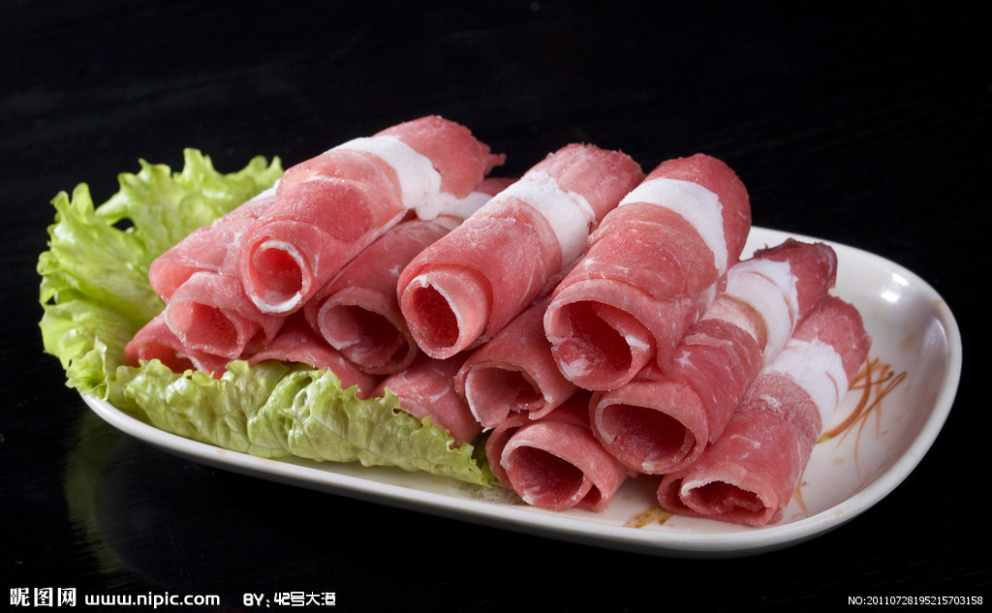

Reference:

<https://www.nipic.com/show/4897557.html>

(*肥牛肉卷摄影图__传统美食_餐饮美食_摄影图库_昵图网nipic.Com*, n.d.)

ID:SDF8ml

**Crispy sausage** (Made from fresh ground pork meat with a unique taste.)

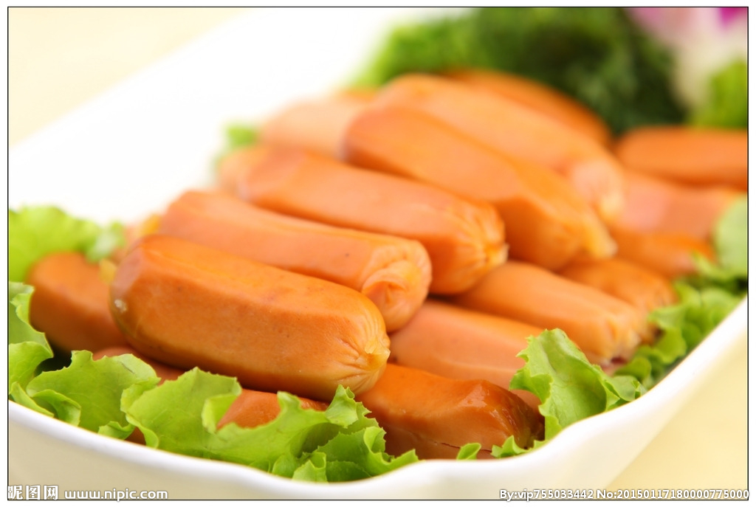

Reference:

<https://www.nipic.com/show/11808822.html>

(*脆皮肠摄影图__传统美食_餐饮美食_摄影图库_昵图网nipic.Com*, n.d.)

ID:9QOAQM

**Spam** (Made from fresh ground pork and flour, the taste is sweet and spicy)

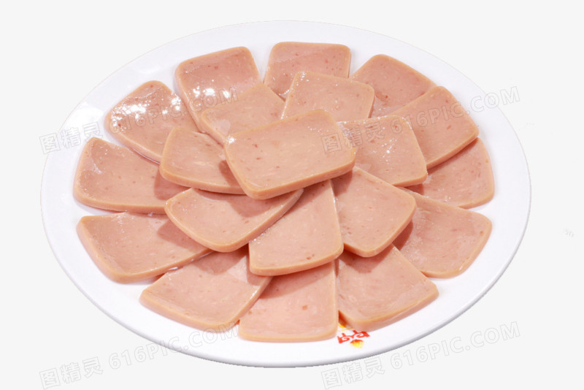

Reference:

<http://616pic.com/sucai/z62i6y5p1.html>

(*午餐肉图片免费下载_PNG素材_编号z62i6y5p1_图精灵*, n.d.)

ID:ZLhCJE

**Beef ball** (Meatballs whipped from the best beef, with a mellow taste.)

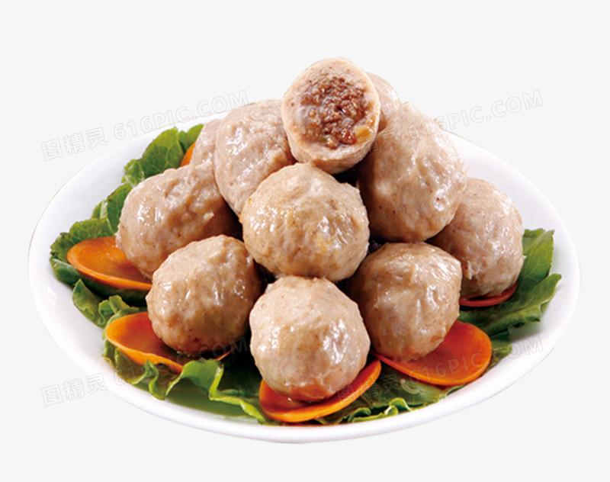

Reference:

<http://616pic.com/sucai/1m9ie4mnv.html>

(*牛肉丸图片免费下载_PNG素材_编号1m9ie4mnv_图精灵*, n.d.)

ID:hRlorO

**Quail Eggs**

Quail eggs are tender and delicious, ready to be eaten in the pot for three minutes.

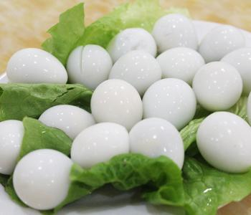

reference:

<https://gimg2.baidu.com/image_search/src=http%3A%2F%2Fwww.cq67.com%2Fuploads%2F2015122526%2F1418800065_56875.jpg&refer=http%3A%2F%2Fwww.cq67.com&app=2002&size=f9999,10000&q=a80&n=0&g=0n&fmt=jpeg?sec=1637528358&t=2a44693deb08fe180fc534d95ba89c63>

(*Src=http://Www.Cq67.Com/Uploads/2015122526/1418800065_56875.Jpg&refer=http://Www.Cq67.Com&app=2002&size=f9999,10000&q=a80&n=0&g=0n&fmt=jpeg (350×300)*, n.d.)

ID:N1jCfv

## Seafoods

**Shrimp**

Shrimp has high nutritional value in diet, and can be steamed or fried. Shrimp is easy to digest and is food for people who are weak and need to be nursed after illness.

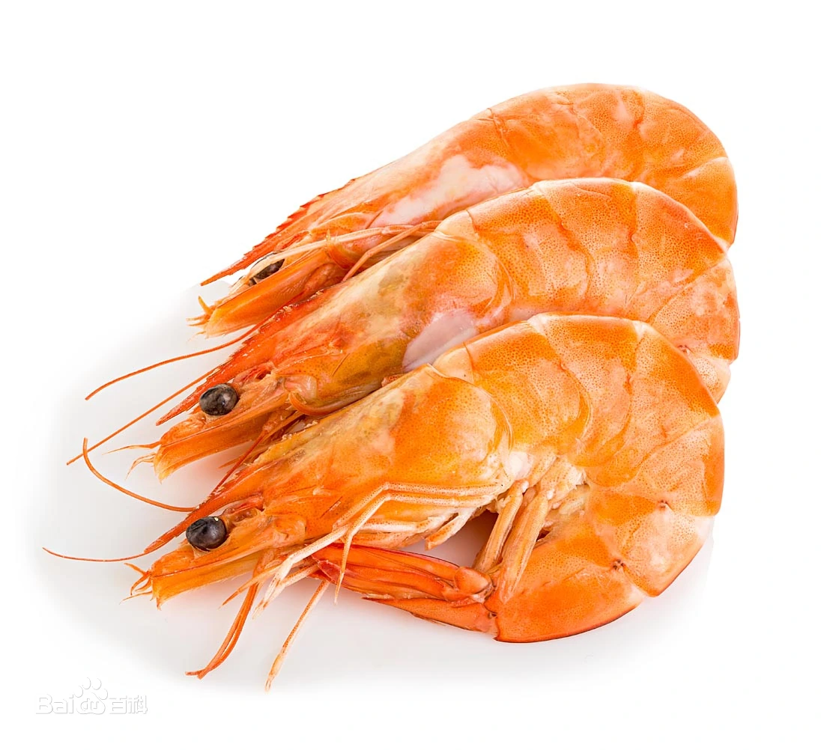

reference: <https://baike.baidu.com/pic/%E8%99%BE/65649/22012181/cc11728b4710b91294cea1a4c9fdfc0392452258?fr=lemma&ct=cover#aid=22012181&pic=cc11728b4710b91294cea1a4c9fdfc0392452258>

(虾图片_百度百科, n.d.)

ID:mcPOmr

**Scallops**

The main nutrient component of the edible part of scallops is protein, which is similar to fish and shrimp. It is an important aquatic food that integrates food, medicine and nourishment. Scallops are widely distributed in all sea areas of the world.

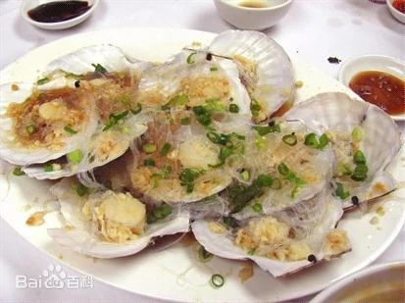

reference: <https://baike.baidu.com/pic/%E6%89%87%E8%B4%9D/1047097/0/4ec2d5628535e5ddac76acf377c6a7efce1b6247?fr=lemma&ct=single#aid=0&pic=4ec2d5628535e5ddac76acf377c6a7efce1b6247>

(扇贝图片_百度百科, n.d.)

ID:I-hDb_

**Squid**

Squid is rich in calcium, phosphorus, and iron, which is good for bone development and hematopoiesis, and can effectively treat anemia. Squid also helps detoxify and detoxify the liver, promotes body metabolism, and has anti-fatigue, nourishing yin and beauty, and anti-aging effects.

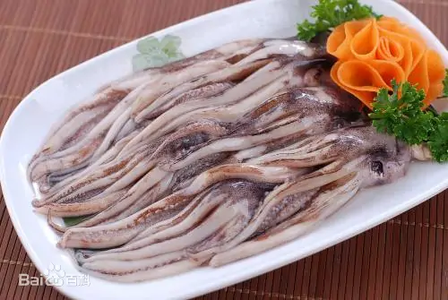

reference：<https://baike.baidu.com/pic/%E9%B1%BF%E9%B1%BC/1025999/0/b58f8c5494eef01fa865dbd1edfe9925bc317db5?fr=lemma&ct=single#aid=0&pic=b58f8c5494eef01fa865dbd1edfe9925bc317db5>

(鱿鱼图片_百度百科, n.d.)

ID:pfnzS4

**Crab stick**

The crab stick is a simulation of the texture and flavor of the crab legs of Alaska snow crab. The meat is firm and tough, with a salty, slightly sweet and delicious seafood flavor, which is very similar.

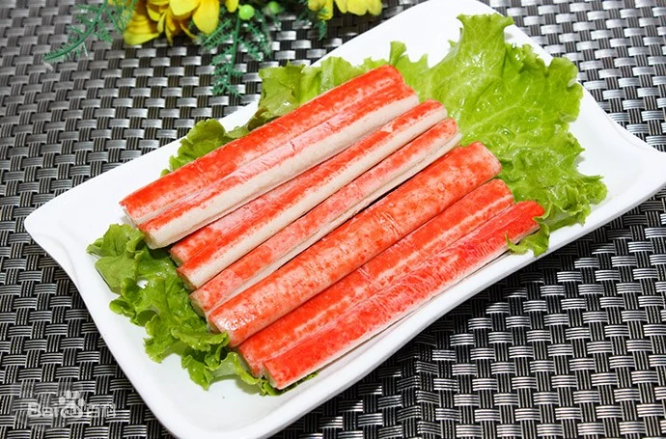

reference:

<https://baike.baidu.com/pic/%E8%9F%B9%E6%A3%92/249331/1/7aec54e736d12f2e49b813ca45c2d562843568df?fr=lemma&ct=single#aid=1&pic=7aec54e736d12f2e49b813ca45c2d562843568df>

(蟹棒图片_百度百科, n.d.)

ID:AQqEj2

**Fish**

Fish is a good tonic aquatic food, not only tastes delicious, but also has high nutritional value. Its protein content is twice that of pork, and it is a high-quality protein with a high absorption rate by the human body. Fish is good for enhancing memory, protecting eyesight, and eliminating inflammation. In addition, most people choose fish with few spines as hot pot ingredients.

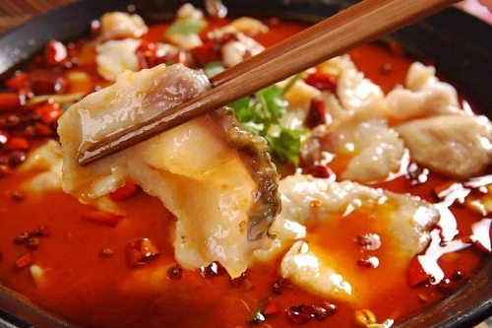

reference:<https://image.baidu.com/search/detail?ct=503316480&z=0&ipn=d&word=%E9%B1%BC%E7%81%AB%E9%94%85&step_word=&hs=0&pn=0&spn=0&di=187440&pi=0&rn=1&tn=baiduimagedetail&is=0%2C0&istype=2&ie=utf-8&oe=utf-8&in=&cl=2&lm=-1&st=-1&cs=1048033057%2C27186748&os=2907353612%2C3663762738&simid=4278536292%2C832411829&adpicid=0&lpn=0&ln=1984&fr=&fmq=1634766334062_R&fm=result&ic=&s=undefined&hd=&latest=&copyright=&se=&sme=&tab=0&width=&height=&face=undefined&ist=&jit=&cg=&bdtype=0&oriquery=&objurl=https%3A%2F%2Fgimg2.baidu.com%2Fimage_search%2Fsrc%3Dhttp%3A%2F%2Fwww.ktui.cn%2Fwp-content%2Fuploads%2F2020%2F04%2F1578999837546890.jpg%26refer%3Dhttp%3A%2F%2Fwww.ktui.cn%26app%3D2002%26size%3Df9999%2C10000%26q%3Da80%26n%3D0%26g%3D0n%26fmt%3Djpeg%3Fsec%3D1637358365%26t%3D4dd355285430cfb457fcf13cfceb41a3&fromurl=ippr_z2C%24qAzdH3FAzdH3Fooo_z%26e3Bfzz5j_z%26e3BvgAzdH3Frjtx7gAzdH3FoiAzdH3FgjofAzdH3Fcc89a_z%26e3Bip4s&gsm=1&rpstart=0&rpnum=0&islist=&querylist=&nojc=undefined&dyTabStr=MCwzLDIsNCwxLDUsNyw4LDYsOQ%3D%3D>

(鱼火锅的搜索结果_百度图片搜索, n.d.)

ID:7VV1jd

## Vegetables

**Cucumber**

Cucumber slices, relieve greasy and oily, are crisp and refreshing, and can be eaten raw.

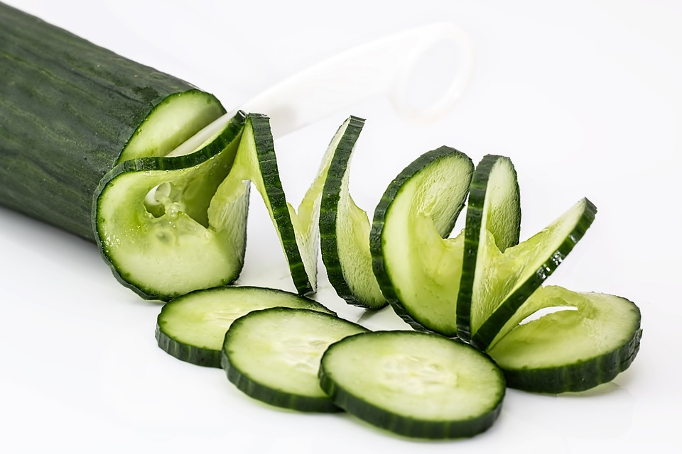

reference:

<https://cdn.pixabay.com/photo/2015/03/23/08/04/cucumber-685704_960_720.jpg>

(*Cucumber-685704_960_720.Jpg (960×640)*, n.d.)

ID:o80vPe

**Bean Sprouts**

Bean sprouts taste slightly spicy and slightly sour, an appetizer.

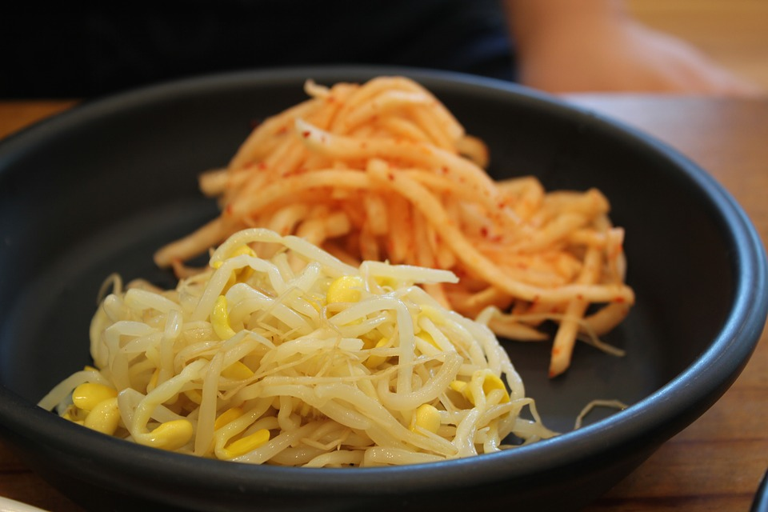

reference:

<https://cdn.pixabay.com/photo/2016/12/21/04/12/side-dish-1922178_960_720.jpg>

(*Side-Dish-1922178_960_720.Jpg (960×640)*, n.d.)

ID:ta1QI_

**Mix-Mushroom**

The mixed assortment of enoki mushrooms and small shiitake mushrooms is put in the thick soup to enhance the umami taste.

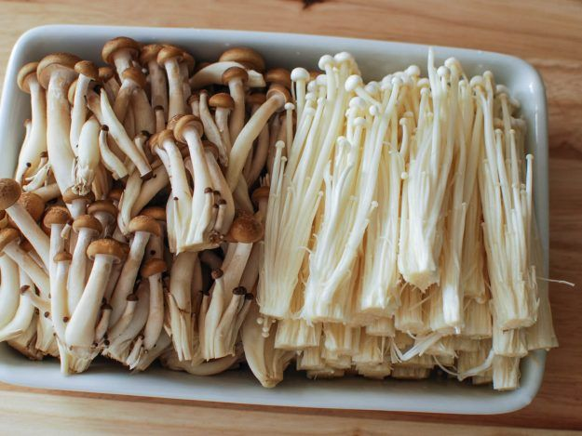

reference:

<https://i.pinimg.com/736x/70/9b/0c/709b0c0c9f6bd553096f82d5b9a7bc28.jpg>

(*709b0c0c9f6bd553096f82d5b9a7bc28.Jpg (625×469)*, n.d.)

ID:cmUofB

**Radish**

Crisp and refreshing white radish is rich in nutrients.

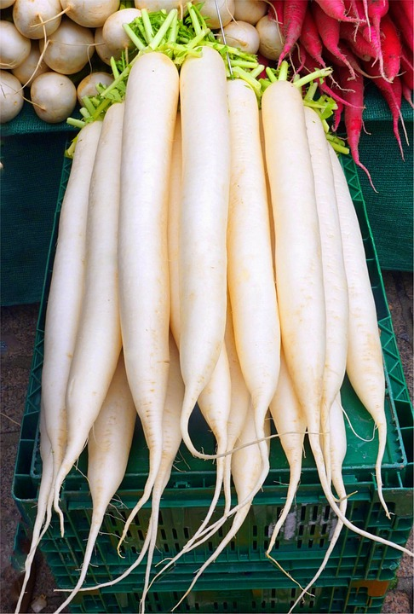

reference:

<https://cdn.pixabay.com/photo/2018/02/13/19/01/radish-3151347_960_720.jpg>

(*Radish-3151347_960_720.Jpg (486×720)*, n.d.)

ID:VLcIQj

**Spinach**

Fresh seasonal vegetables are more oil-absorbing and taste refreshing.

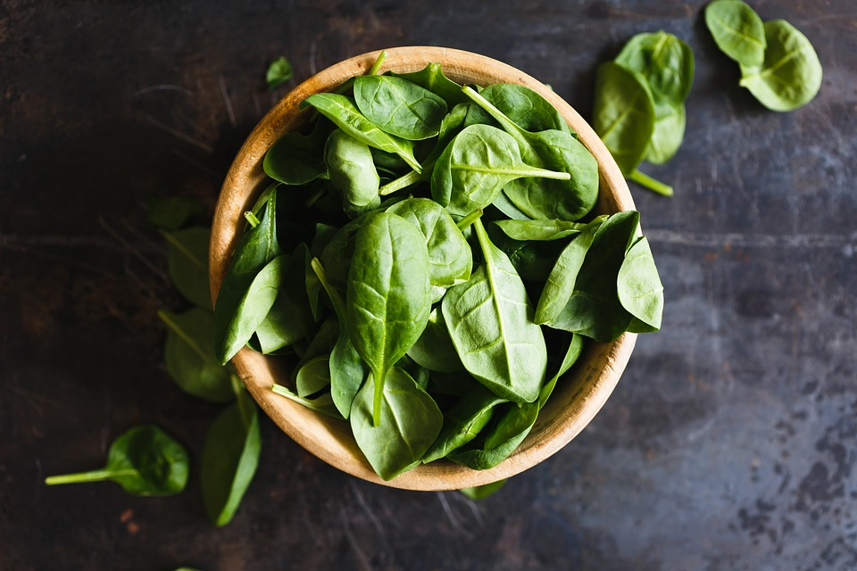

reference:

<https://cdn.pixabay.com/photo/2016/03/10/18/44/top-view-1248955_960_720.jpg>

(*Top-View-1248955_960_720.Jpg (960×640)*, n.d.)

ID:ejA1s3

**Potato**

Potato chips, crisp and refreshing.

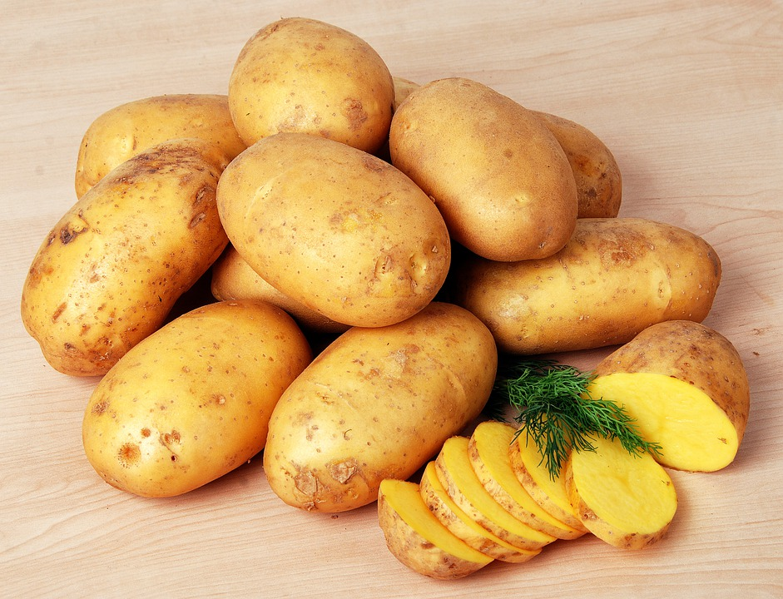

reference:

<https://cdn.pixabay.com/photo/2021/10/18/09/30/vegetable-6720516_960_720.jpg>

(*Vegetable-6720516_960_720.Jpg (941×720)*, n.d.)

ID:2jNov6

**Bean Curd**

Tofu skins, dried tofu skins made by extracting moisture from the tofu. It is soft and glutinous and tastes great.

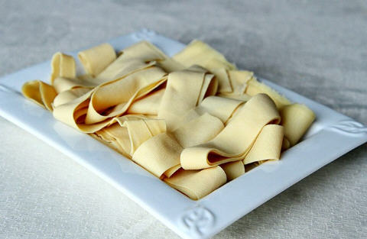

reference:

<https://www.jucanw.com/UploadFiles/2017/2/2017071217393086664.jpg>

(*2017071217393086664.Jpg (480×313)*, n.d.)

ID:P0iygd

**Tofu**

Water milled tofu melts in the mouth and can be eaten after tens of seconds in the pot.

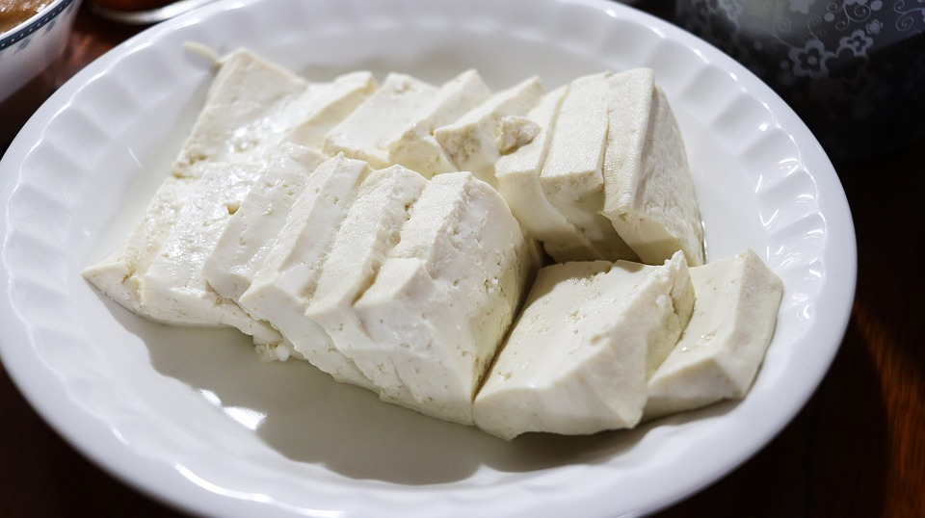

reference:

<https://cdn.pixabay.com/photo/2019/03/26/01/14/tofu-4081697_960_720.jpg>

(*Tofu-4081697_960_720.Jpg (960×538)*, n.d.)

ID:InDzYF

## Main

Steam Rice

Steamed white rice just out of the pot.

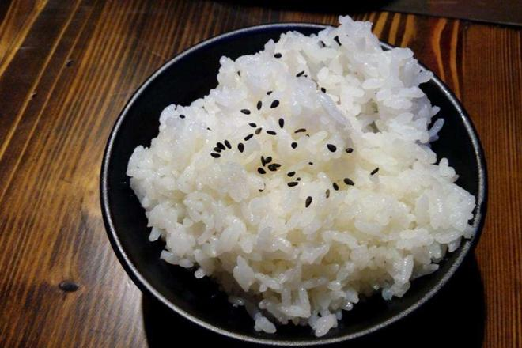

reference:

<https://gimg2.baidu.com/image_search/src=http%3A%2F%2Finews.gtimg.com%2Fnewsapp_match%2F0%2F10966604989%2F0.jpg&refer=http%3A%2F%2Finews.gtimg.com&app=2002&size=f9999,10000&q=a80&n=0&g=0n&fmt=jpeg?sec=1637528642&t=45b26d831e2e3b98134c545917d519ab>

(*Src=http://Inews.Gtimg.Com/Newsapp_match/0/10966604989/0.Jpg&refer=http://Inews.Gtimg.Com&app=2002&size=f9999,10000&q=a80&n=0&g=0n&fmt=jpeg (660×440)*, n.d.)

ID:b-zchC

Noodles

Instant hand ramen noodles, boil in a pot, and eat.

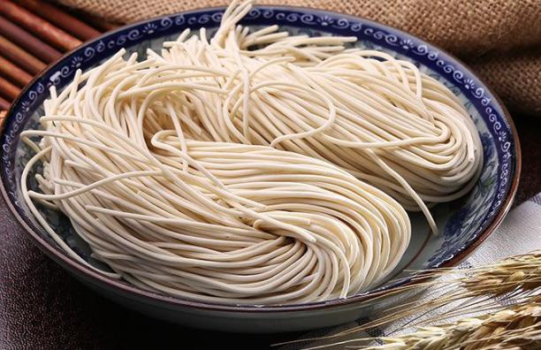

reference:

<https://gimg2.baidu.com/image_search/src=http%3A%2F%2Fimg.022sunny.com%2F2020%2F01%2FY9OTzVw9S8Zx.png&refer=http%3A%2F%2Fimg.022sunny.com&app=2002&size=f9999,10000&q=a80&n=0&g=0n&fmt=jpeg?sec=1637528802&t=f1cf04aba9d5775c212e00e11aa78755>

(*Src=http://Img.022sunny.Com/2020/01/Y9OTzVw9S8Zx.Png&refer=http://Img.022sunny.Com&app=2002&size=f9999,10000&q=a80&n=0&g=0n&fmt=jpeg (612×396)*, n.d.)

ID:iR_zD5

## Sauces

**Garlic**

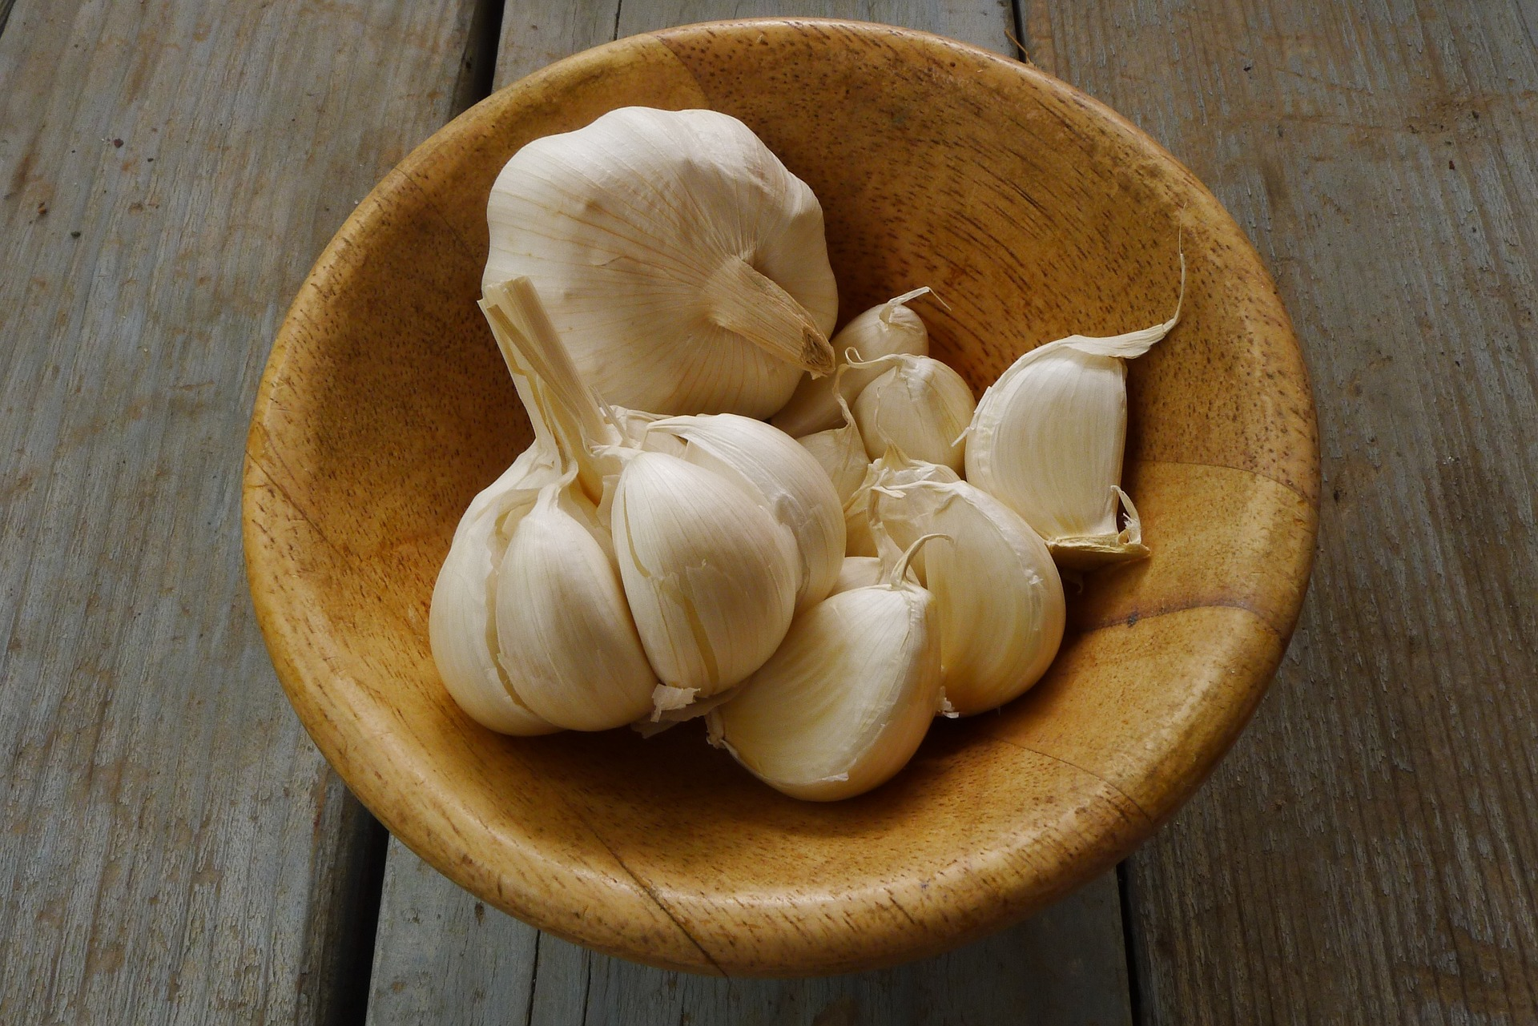

Garlic, peel the garlic and mash it into a puree, it becomes garlic puree. It is mostly used as a condiment and can also be used medicinally.

href:<https://pixabay.com/photos/garlic-organic-fresh-vegetable-1374329/>

(*Pixabay上的免费图片 - 大蒜, 有机的, 新鲜的, 蔬菜, 生产, 棕色蔬菜*, n.d.)

ID:94IgCt

**Tahini**

Tahini is a paste made from sesame seeds and is the staple food of many cuisines, especially in the Mediterranean and the Middle East. It is vegan, gluten-free, has a nutty taste, and is easy to make.

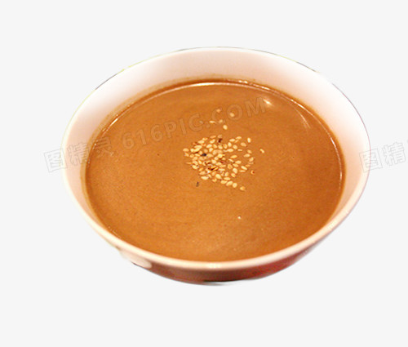

reference: <http://616pic.com/sucai/13gieej0d.html>

(*碗中的芝麻酱图片图片免费下载_PNG素材_编号13gieej0d_图精灵*, n.d.)

ID:0sxToB

**sesame oil**

The sesame oil is originally from hemp seeds, it is a tasty and healthy fat. It is the best partner of garlic sauces which brings you a special flavour when you having it with beef or lamb rolls.

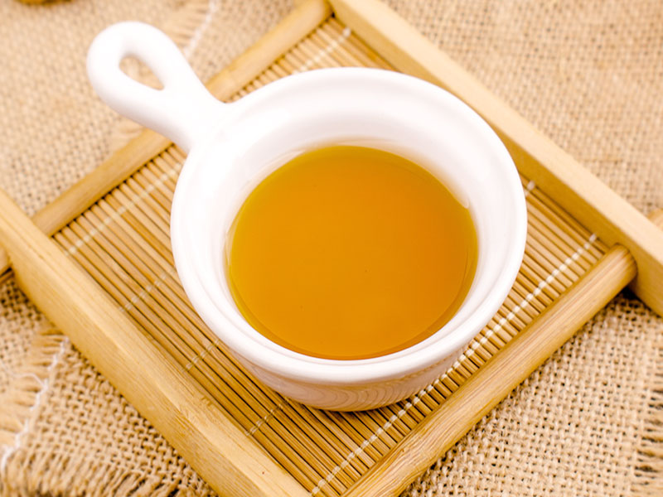

reference: <https://image.baidu.com/search/detail?ct=503316480&z=0&ipn=d&word=%E9%BA%BB%E6%B2%B9&step_word=&hs=0&pn=48&spn=0&di=880&pi=0&rn=1&tn=baiduimagedetail&is=0%2C0&istype=2&ie=utf-8&oe=utf-8&in=&cl=2&lm=-1&st=-1&cs=1315596092%2C3462809967&os=2573573746%2C4164795326&simid=4120075002%2C624902206&adpicid=0&lpn=0&ln=1643&fr=&fmq=1634933760744_R&fm=detail&ic=0&s=undefined&hd=undefined&latest=undefined&copyright=undefined&se=&sme=&tab=0&width=&height=&face=undefined&ist=&jit=&cg=&bdtype=0&oriquery=&objurl=https%3A%2F%2Fgimg2.baidu.com%2Fimage_search%2Fsrc%3Dhttp%3A%2F%2Fpic111.huitu.com%2Fres%2F20181109%2F1873621_20181109164027995070_1.jpg%26refer%3Dhttp%3A%2F%2Fpic111.huitu.com%26app%3D2002%26size%3Df9999%2C10000%26q%3Da80%26n%3D0%26g%3D0n%26fmt%3Djpeg%3Fsec%3D1637525805%26t%3D40ba09ba53525d6a37541a8d66f91299&fromurl=ippr_z2C%24qAzdH3FAzdH3Fooo_z%26e3Bgtrtv_z%26e3Bv54AzdH3F1jpwtsAzdH3Fi7tp7AzdH3Fda8b88alAzdH3F8m9ad0llca0a_z%26e3Bip4s&gsm=2d&rpstart=0&rpnum=0&islist=&querylist=&nojc=undefined>

(麻油的搜索结果_百度图片搜索, n.d.)

ID:VOl9Hr

**Chili oil**

Chili oil is a seasoning, and its preparation method is quite particular. Generally, chili and various ingredients are deep-fried.

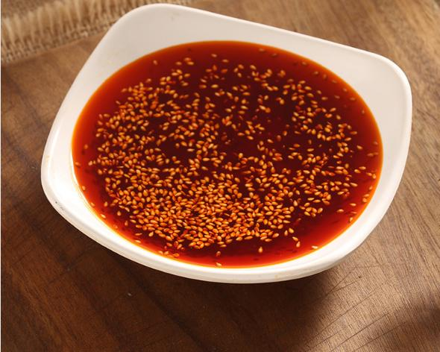

reference:<https://image.baidu.com/search/detail?ct=503316480&z=0&ipn=d&word=%E8%BE%A3%E6%A4%92%E6%B2%B9&step_word=&hs=0&pn=1&spn=0&di=8140&pi=0&rn=1&tn=baiduimagedetail&is=0%2C0&istype=0&ie=utf-8&oe=utf-8&in=&cl=2&lm=-1&st=undefined&cs=3358641354%2C946549036&os=1568698003%2C2080499159&simid=3494750244%2C275757761&adpicid=0&lpn=0&ln=1821&fr=&fmq=1634934757590_R&fm=&ic=undefined&s=undefined&hd=undefined&latest=undefined&copyright=undefined&se=&sme=&tab=0&width=undefined&height=undefined&face=undefined&ist=&jit=&cg=&bdtype=0&oriquery=&objurl=https%3A%2F%2Fgimg2.baidu.com%2Fimage_search%2Fsrc%3Dhttp%3A%2F%2Fimg003.hc360.cn%2Fk2%2FM0A%2F8C%2F3C%2FsQ69805a2f7e15213ae3eaBC16C925af1e8.png%26refer%3Dhttp%3A%2F%2Fimg003.hc360.cn%26app%3D2002%26size%3Df9999%2C10000%26q%3Da80%26n%3D0%26g%3D0n%26fmt%3Djpeg%3Fsec%3D1637526776%26t%3D455df7e6d1a937eb8d37797c1641ce1c&fromurl=ippr_z2C%24qAzdH3FAzdH3Fkdk_z%26e3Bivnma_z%26e3Bv54AzdH3FetjoPtvfAzdH3Ff7rrsyfjsu_rtvfAzdH3Fmbmcnc9d8_z%26e3Bip4s&gsm=2&rpstart=0&rpnum=0&islist=&querylist=&nojc=undefined&dyTabStr=MCwzLDIsNiwxLDUsNCw4LDcsOQ%3D%3D>

(辣椒油的搜索结果_百度图片搜索, n.d.)

ID:Z6YAZ0

**Beef sauce**

Beef sauce is a condiment based on beef.

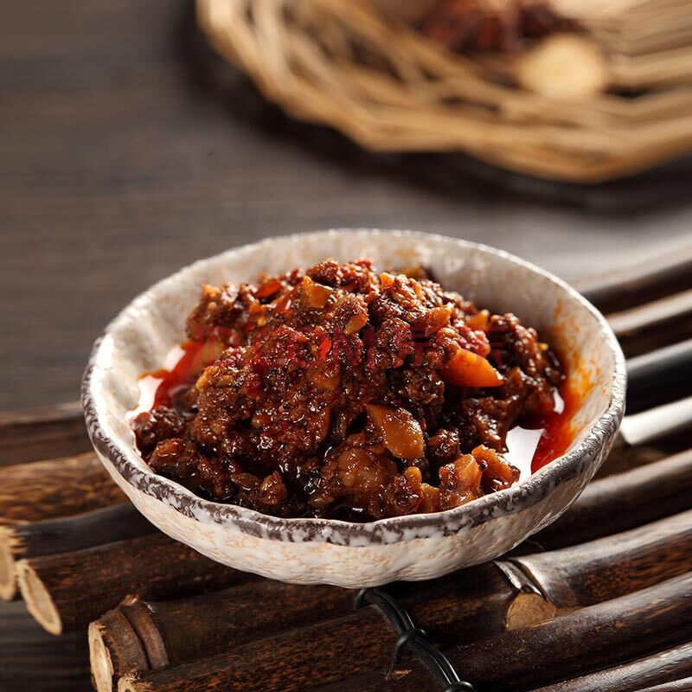

reference:<https://image.baidu.com/search/detail?ct=503316480&z=0&ipn=d&word=%E7%89%9B%E8%82%89%E9%85%B1&step_word=&hs=0&pn=0&spn=0&di=202070&pi=0&rn=1&tn=baiduimagedetail&is=0%2C0&istype=0&ie=utf-8&oe=utf-8&in=&cl=2&lm=-1&st=undefined&cs=3559725035%2C3818680099&os=2599464775%2C3716759718&simid=3408568703%2C242154813&adpicid=0&lpn=0&ln=1886&fr=&fmq=1634935071845_R&fm=&ic=undefined&s=undefined&hd=undefined&latest=undefined&copyright=undefined&se=&sme=&tab=0&width=undefined&height=undefined&face=undefined&ist=&jit=&cg=&bdtype=0&oriquery=&objurl=https%3A%2F%2Fgimg2.baidu.com%2Fimage_search%2Fsrc%3Dhttp%3A%2F%2Fimg11.360buyimg.com%2Fn0%2Fjfs%2Ft1%2F104952%2F32%2F14656%2F125220%2F5e6861c3Eb66015f9%2F34de758b6bbe29ba.jpg%26refer%3Dhttp%3A%2F%2Fimg11.360buyimg.com%26app%3D2002%26size%3Df9999%2C10000%26q%3Da80%26n%3D0%26g%3D0n%26fmt%3Djpeg%3Fsec%3D1637527157%26t%3Db6305347d5345fa6abd1e099fd61a8a4&fromurl=ippr_z2C%24qAzdH3FAzdH3Fooo_z%26e3B46fi7i7w_z%26e3BgjpAzdH3Ffirupy27i26p22AzdH3F&gsm=1&rpstart=0&rpnum=0&islist=&querylist=&nojc=undefined&dyTabStr=MCwzLDIsNiwxLDQsNSw4LDcsOQ%3D%3D>

(牛肉酱的搜索结果_百度图片搜索, n.d.)

ID:xRPM9F

## **Beverages**

**1. Pepsi**

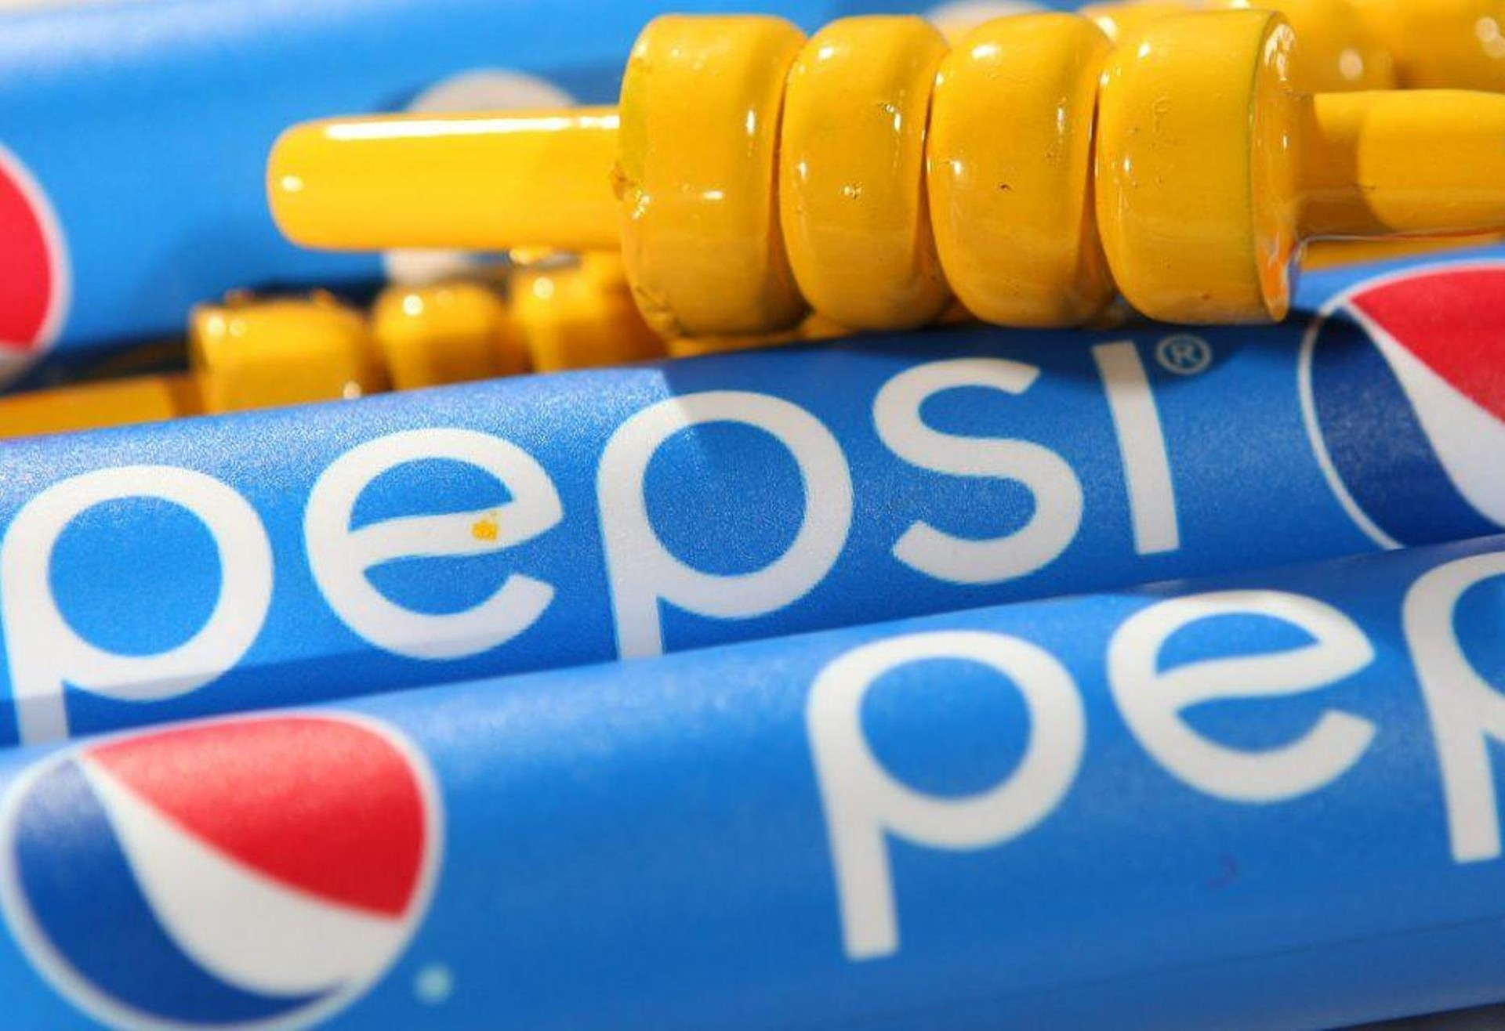

Everyone loves Pepsi, isn’t it?

Image by PixArc from [Pixabay](https://pixabay.com/?utm_source=link-attribution&utm_medium=referral&utm_campaign=image&utm_content=5016273)

herf: <https://pixabay.com/zh/photos/pepsi-brand-banner-poster-734274/>

(*Pixabay上的免费图片 - 百事可乐, 品牌, 横幅, 海报, 广告, 蟋蟀, 树桩, 蓝色横幅*, n.d.-a)

ID:EwT8lP

**2.Cola**

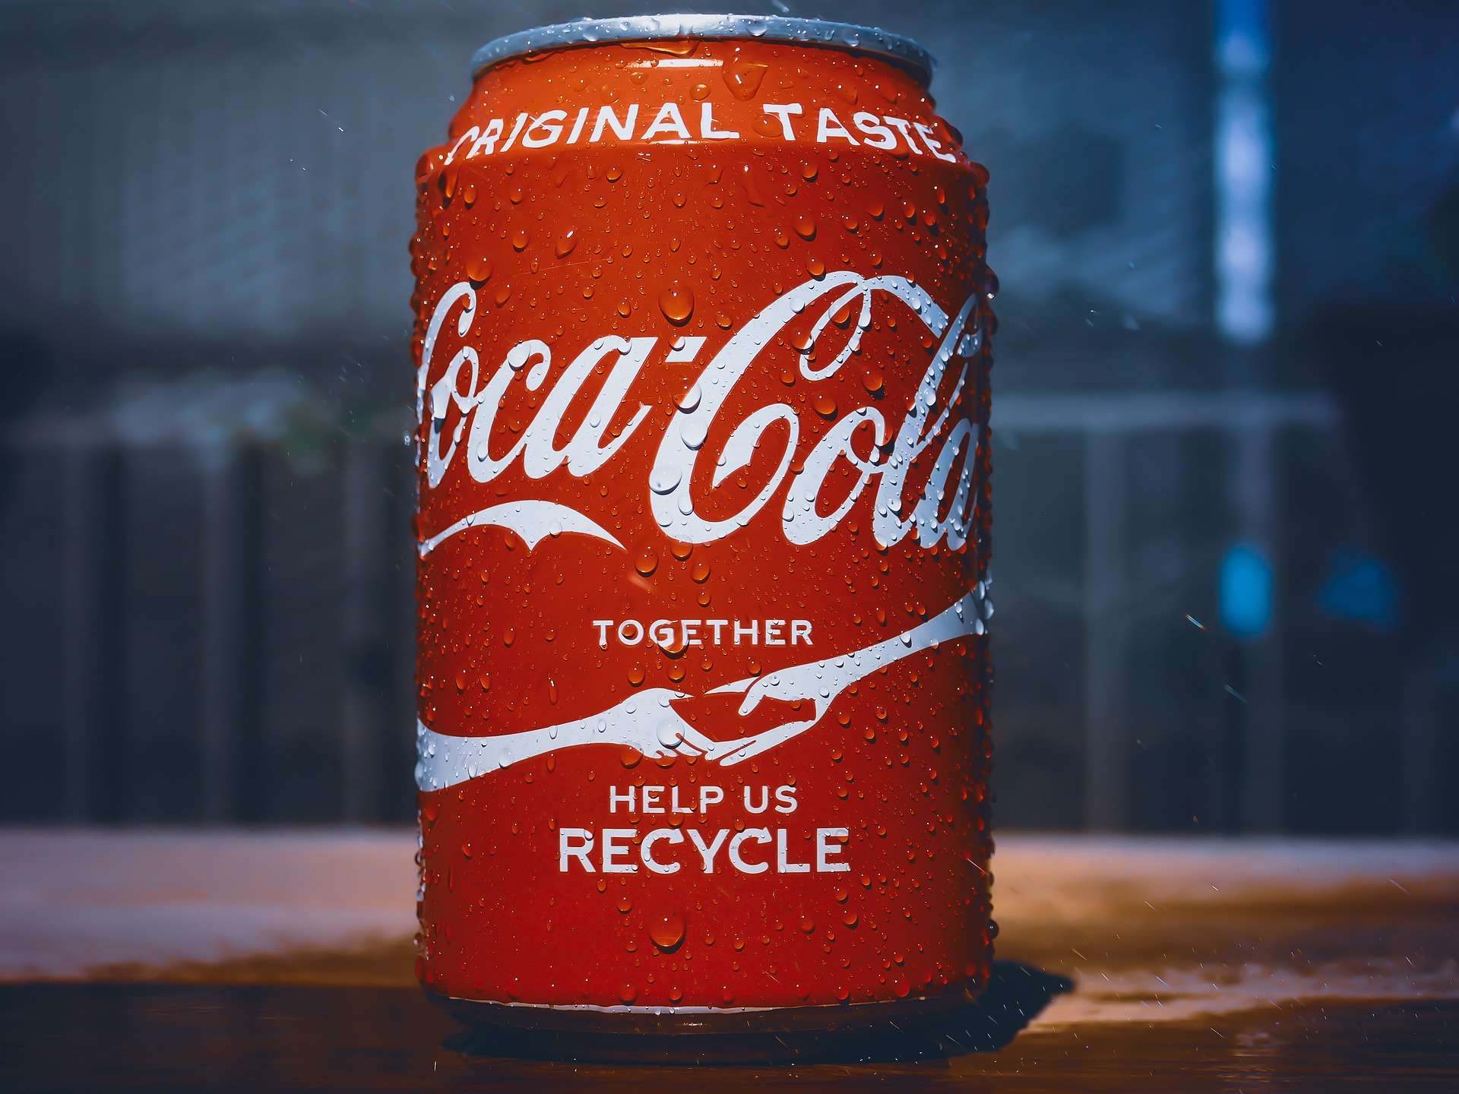

If you are not a big fan of Pepsi, Cola must be your second choice.

Image by [Ervin Gjata](https://pixabay.com/users/5075933-5075933/?utm_source=link-attribution&utm_medium=referral&utm_campaign=image&utm_content=5016273) from [Pixabay](https://pixabay.com/?utm_source=link-attribution&utm_medium=referral&utm_campaign=image&utm_content=5016273)

herf: <https://pixabay.com/photos/pepsi-brand-banner-poster-734274/>

(*Pixabay上的免费图片 - 百事可乐, 品牌, 横幅, 海报, 广告, 蟋蟀, 树桩, 蓝色横幅*, n.d.-b)

ID:0LRg7Q

**3.Orange Juice**

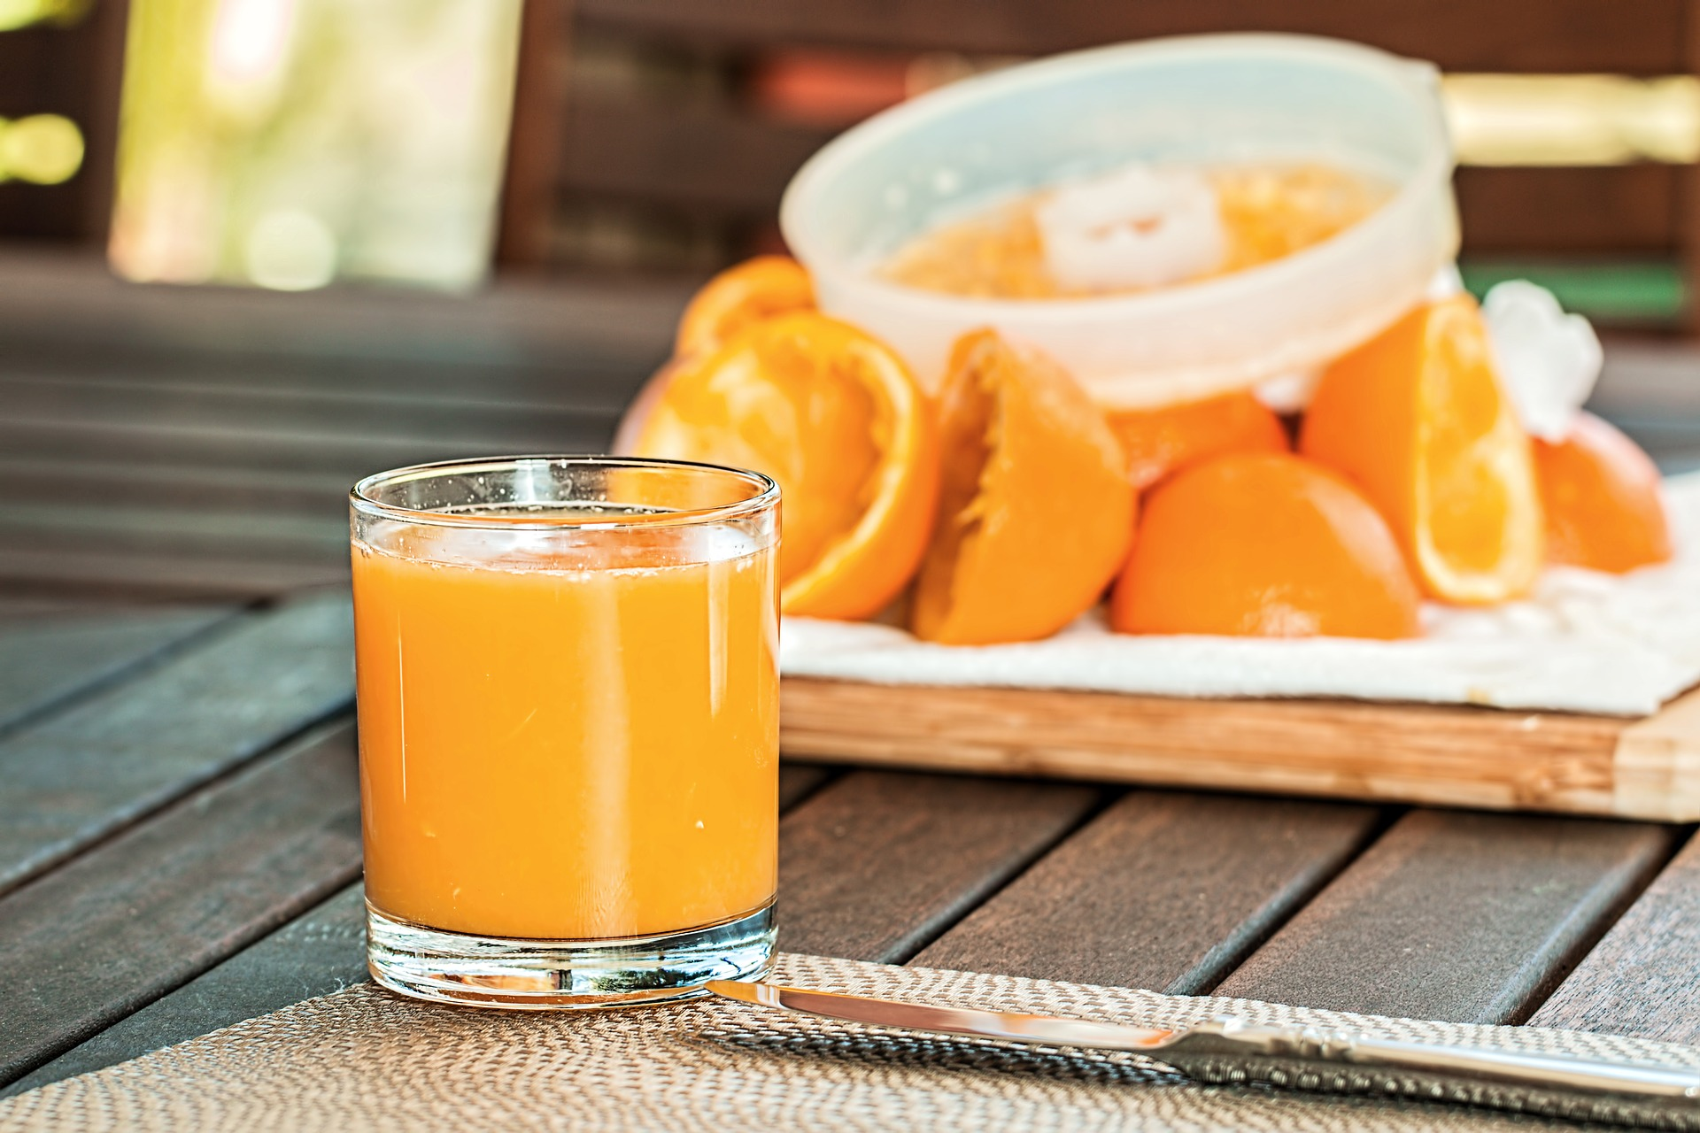

Homemade orange juice, 100% orange! no water or sugar inside.

Image by [Steve Buissinne](https://pixabay.com/users/stevepb-282134/?utm_source=link-attribution&utm_medium=referral&utm_campaign=image&utm_content=1614822) from [Pixabay](https://pixabay.com/?utm_source=link-attribution&utm_medium=referral&utm_campaign=image&utm_content=1614822)

herf: <https://pixabay.com/photos/fresh-orange-juice-squeezed-1614822/>

(*Pixabay上的免费图片 - 新鲜橙汁, 挤压, 提神醒脑, 柑橘, 喝, 维生素 C, 桔子汁*, n.d.)

ID:skG42j

**4.Soda**

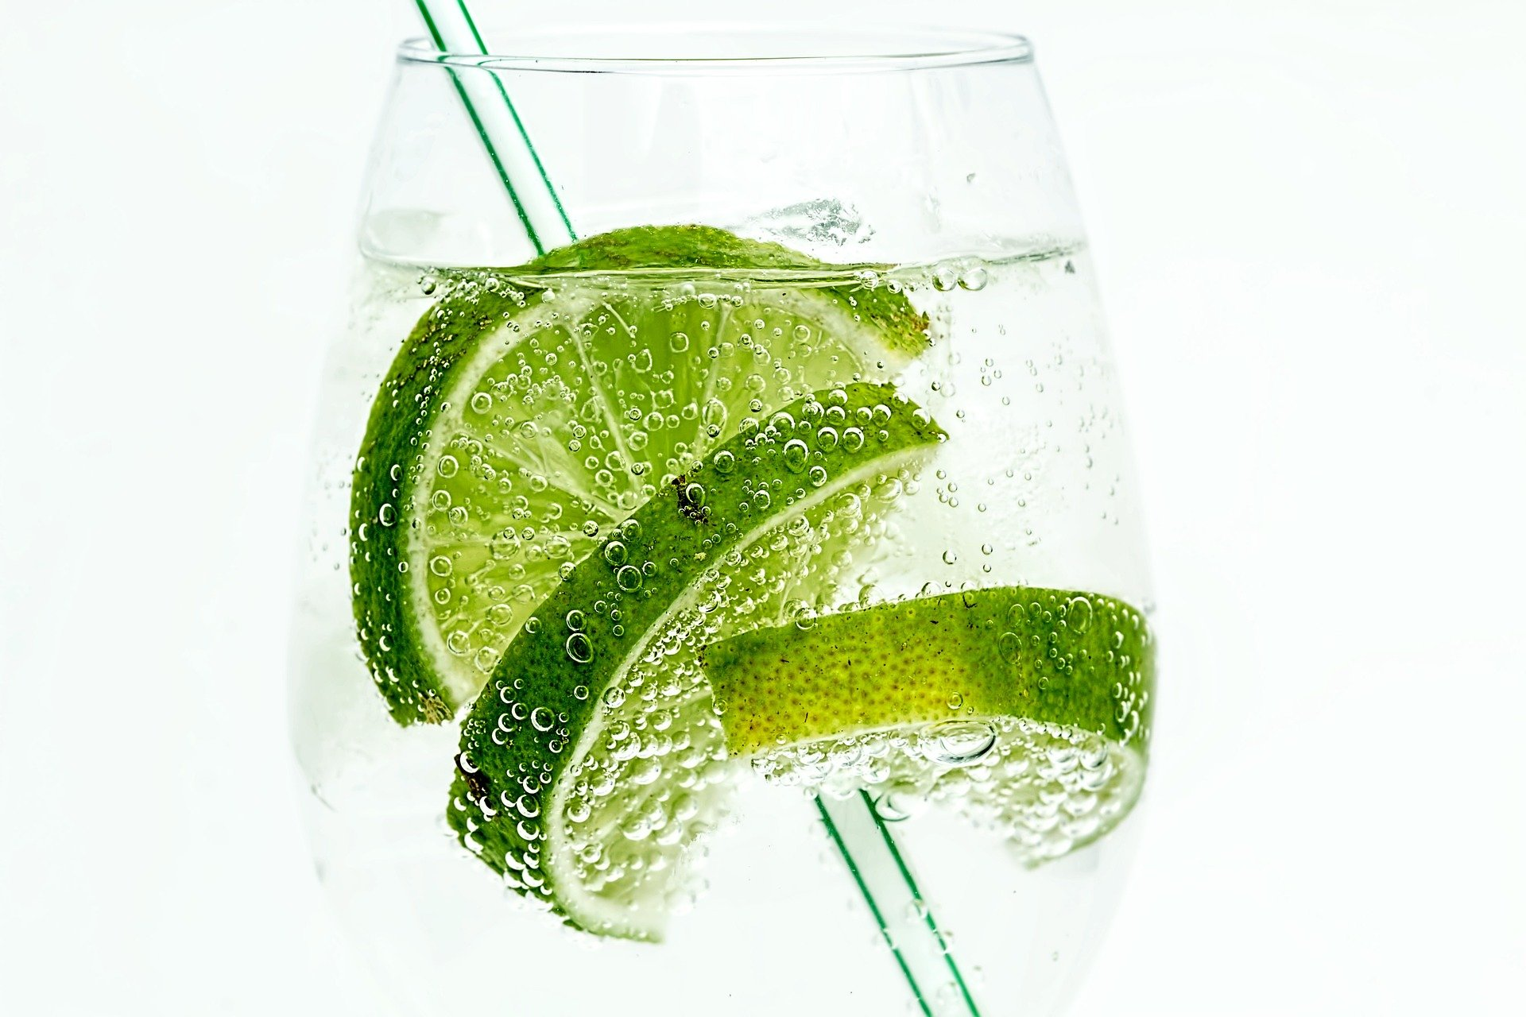

Hotpot’s best friend!

Image by [Steve Buissinne](https://pixabay.com/users/stevepb-282134/?utm_source=link-attribution&utm_medium=referral&utm_campaign=image&utm_content=907124) from [Pixabay](https://pixabay.com/?utm_source=link-attribution&utm_medium=referral&utm_campaign=image&utm_content=907124)

herf:<https://pixabay.com/photos/lime-drink-glass-club-soda-907124/>

(*Pixabay上的免费图片 - 酸橙, 喝, 玻璃, 玻璃, 苏打水, 鸡尾酒, 果汁, 寒冷的*, n.d.)

ID:JJzSOS

**5.Apple Juice**

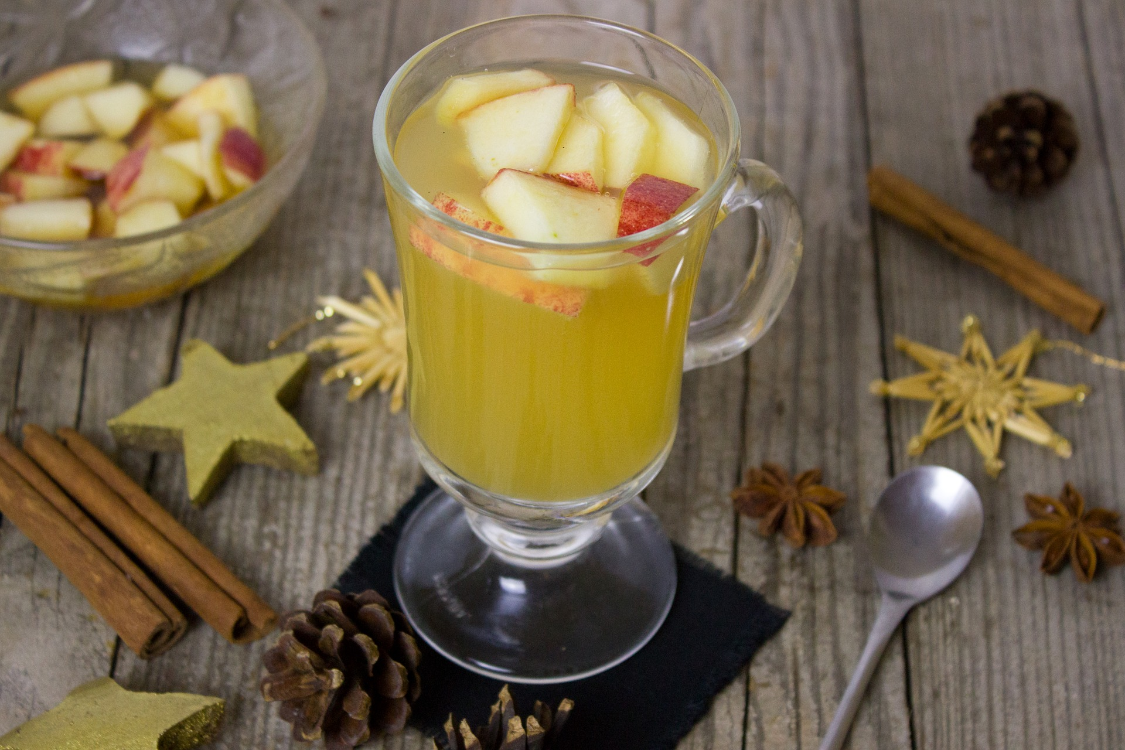

Homemade apple juice, 100% made with fresh apples.

Image by [Bernadette Wurzinger](https://pixabay.com/users/einladung_zum_essen-3625323/?utm_source=link-attribution&utm_medium=referral&utm_campaign=image&utm_content=1866178) from [Pixabay](https://pixabay.com/?utm_source=link-attribution&utm_medium=referral&utm_campaign=image&utm_content=1866178)

herf:<https://pixabay.com/photos/punch-apple-apples-apple-juice-1866178/>

(*Pixabay上的免费图片 - 打孔, 苹果, 苹果汁, 杏仁, 喝, 热的, 热饮, 圣诞节, 来临*, n.d.)

ID:MgHhvB

# About Us (ID:4zeV41)

Bring the finest and freshest foods to our customers, is our first priority in Treasure Pot.

Feeling hungry and having difficulty of choosing a restaurant? Try Treasure Pot! Our menu provides more than 30 different kinds of food, fish, beef, lamb, chicken, shrimp, and a bunch of other home special cuisines, and they are all you can eat!

Food quality is the least thing you need to worry about in Treasure Pot. In order to deliver the best taste to our customers, all of our foods are ordered from our exclusive factory. And to make sure of the freshness, every unused ingredient which lasts two days will be replaced by new ingredients.

What are you waiting for? Come and taste!

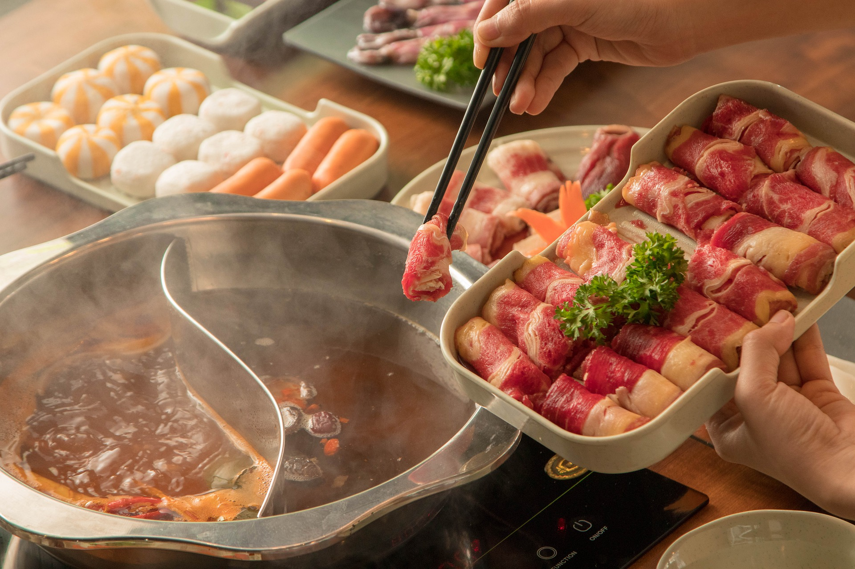

Come and enjoy the food!

Image by Chupanh.vn Studio from Pixabay (2021.Oct 22nd)

href:<https://pixabay.com/photos/beef-meat-beef-hotpot-food-cuisine-5916072/>

(*Pixabay上的免费图片 - 牛肉, 肉, 牛肉的火锅, 食物, 美食, 准备, 烹饪, 配料*, n.d.)

ID:FWIS3D

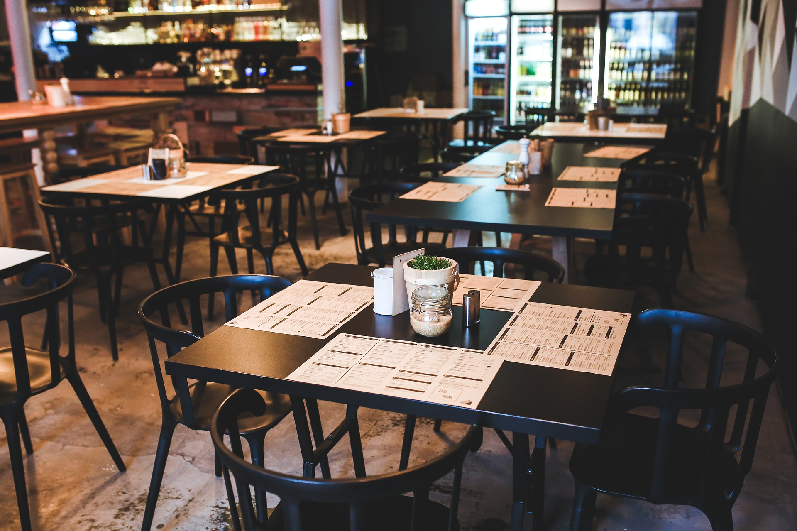

The tables and chairs in our restaurant are as clean as new.

Image by [Karolina Grabowska](https://pixabay.com/users/kaboompics-1013994/?utm_source=link-attribution&utm_medium=referral&utm_campaign=image&utm_content=791167) from [Pixabay](https://pixabay.com/?utm_source=link-attribution&utm_medium=referral&utm_campaign=image&utm_content=791167) (2021.Oct 22nd)

href: <https://pixabay.com/photos/table-chairs-chair-restaurant-791167/>

(*Pixabay上的免费图片 - 表, 椅子, 餐厅, 优质的, 复古的, 内部的, 设计, 菜单*, n.d.)

ID:ZnnS1I

## Chef

Our chef Fred graduated from Le Cordon Bleu Culinary School in Los Angeles. He has decades of cooking experience, especially has his unique insights into Chinese hot pot cuisine and Sichuan cuisine.

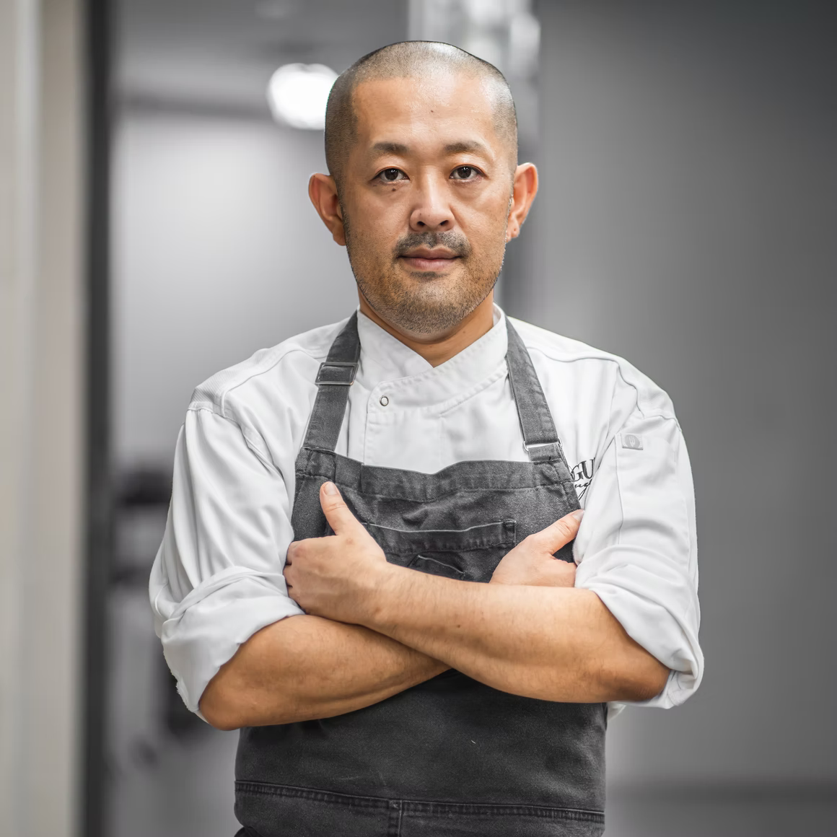

Img Source: <https://unsplash.com/photos/FMh5o5m5N9E>

(Unsplash, n.d.)

ID:QQJ2hW

## Restaurant Seating Map

In our restaurant, we have set up three large tables for up to 6 people, seven medium tables for up to 4 people, and seven small tables for up to 2 people. Due to the pandemic, we will limit the number of people in our restaurant. We are sorry for any inconvenience to you.



Img Source: <https://fpg.roomsketcher.com/image/topic/24/image/Restaurant-3D-Floor-Plan.jpg>

(*Restaurant-3D-Floor-Plan.Jpg (1600×791)*, n.d.)

ID:1l2SM9

# Contact Us

Phone: +1(902) 888 8888 (ID:IIWT0l)

Email: [treasurepot@gmail.com](mailto:treasurepot@gmail.com) (ID:S64f8A)

Address: 1234 Granville St, Halifax, NS, B3K 1N7 (ID:GusDFU)



Wonderful views outside our restaurant.

Image by Paul_Henri from [Pixabay](https://pixabay.com/?utm_source=link-attribution&utm_medium=referral&utm_campaign=image&utm_content=791167) (2021.Oct 22nd)

herf: <https://pixabay.com/photos/resort-beach-seaside-resort-4471852/>

(*Pixabay上的免费图片 - 采取, 海滩, 海滨度假胜地, 餐厅, 海桥, 出卖, 波罗的海*, n.d.)

ID:Vs1t9E

# Menu(combo)

Combo for 1 person (lunch) - Wu (ID:MgoO5w)

Combo introduction: The combo is to provide the fastest dining experience for one person. Customers can use the shortest time to enjoy the fun of hot pot and wealthy dishes.

Included dishes: A soup base (choose your own taste), a source (choose your own taste), a lamb roll, a beef roll, a crispy sausage, a crab stick, a shrimp, a fish, a bean curd, a spinach, a mix-mushroom, a rice, a drink (choose your own taste).

Price: $25.99

Combo for 2 or 3 people (lunch) - Yao (ID:WT4n-i)

Meat lover? No worries! In this lunch combo, we provide all meat deals! From ocean to land, everything you want from the munu, you will have it.

Includes: one soup base; up to 6 same or different kinds of meat from our entire menu; 2 serves of rice; 2 cans of drinks;

Price:$59.99

Combo for 1 person (dinner) - Wan (ID:wPTRFc)

Combination introduction: An affordable single dinner combo, rich meat and vegetable mix, balanced nutrition, and enjoy delicious hot pot without wasting.

Included dishes: A soup base (choose your own taste), a source (choose your own taste), all dishes are all-you-can-eat, one drink and one staple food.

Price: $29.99

Combo for 2 or 3 people (dinner) - Yang (ID:X8g878)

Combination introduction: This combination is suitable for a whole family to enjoy, customers can experience our various cuisine features, including our signature seafood and meat.

Contains dishes: A soup base (choose your own taste), a source (choose your own taste), 3 lamb rolls, 3 beef rolls, 3 Quail Eggs, 3 Tofu ,3 Bean Curd and Radish

Price: $80

Combo For Up to 6 People (Dinner) - Tang (ID:E-10T2)

Want to enjoy a lively and warm Sichuan hot pot with your family or friends? This combo is specially designed for a whole party, providing you with a wide variety of dishes, offering you an excellent opportunity to enjoy the party time with your family or friends!

Include: up to 3 different soup bases (choose your own taste), up to 6 sources (choose your own taste), up to 6 different drinks, unlimited rice and noodles, Shrimp, Scallops, Squid, Fish, Lamb roll, Beef roll, Beef ball, Spinach, Radish, Mix-Mushroom, Tofu, Potato, Cucumber, Bean Sprouts, Quail Eggs.

Price: $149.99

Doucument format arranged by Jiaxiong Yao

Content contributors are listed in the “Provider” column in the Content Inventory Sheet.

## Reference

0fazTSXBltE8NS2E8FC1zSK7XzYmz2NOFFE7kE-4_Vt8ho6p7_gxi8ZVgPTI1Cd2joJrvItByyS4HHaWdXyO_DrXIaWutJls2xCVbatkhjUNNiIYVnHvzugZCuBITtvjski7YaLlHpkrQUr5euoQrg.jpg (700×700). (n.d.). Retrieved October 22, 2021, from http://qcloud.dpfile.com/pc/0fazTSXBltE8NS2E8FC1zSK7XzYmz2NOFFE7kE-4_Vt8ho6p7_gxi8ZVgPTI1Cd2joJrvItByyS4HHaWdXyO_DrXIaWutJls2xCVbatkhjUNNiIYVnHvzugZCuBITtvjski7YaLlHpkrQUr5euoQrg.jpg

709b0c0c9f6bd553096f82d5b9a7bc28.jpg (625×469). (n.d.). Retrieved October 22, 2021, from https://i.pinimg.com/736x/70/9b/0c/709b0c0c9f6bd553096f82d5b9a7bc28.jpg

2017071217393086664.jpg (480×313). (n.d.). Retrieved October 22, 2021, from https://www.jucanw.com/UploadFiles/2017/2/2017071217393086664.jpg

Cucumber-685704_960_720.jpg (960×640). (n.d.). Retrieved October 22, 2021, from https://cdn.pixabay.com/photo/2015/03/23/08/04/cucumber-685704_960_720.jpg

Pixabay上的免费图片—大蒜, 有机的, 新鲜的, 蔬菜, 生产, 棕色蔬菜. (n.d.). Retrieved October 22, 2021, from https://pixabay.com/zh/photos/garlic-organic-fresh-vegetable-1374329/

Pixabay上的免费图片—打孔, 苹果, 苹果汁, 杏仁, 喝, 热的, 热饮, 圣诞节, 来临. (n.d.). Retrieved October 22, 2021, from https://pixabay.com/zh/photos/punch-apple-apples-apple-juice-1866178/

Pixabay上的免费图片—新鲜橙汁, 挤压, 提神醒脑, 柑橘, 喝, 维生素 C, 桔子汁. (n.d.). Retrieved October 22, 2021, from https://pixabay.com/zh/photos/fresh-orange-juice-squeezed-1614822/

Pixabay上的免费图片—牛肉, 肉, 牛肉的火锅, 食物, 美食, 准备, 烹饪, 配料. (n.d.). Retrieved October 22, 2021, from https://pixabay.com/zh/photos/beef-meat-beef-hotpot-food-cuisine-5916072/

Pixabay上的免费图片—百事可乐, 品牌, 横幅, 海报, 广告, 蟋蟀, 树桩, 蓝色横幅. (n.d.-a). Retrieved October 22, 2021, from https://pixabay.com/zh/photos/pepsi-brand-banner-poster-734274/

Pixabay上的免费图片—百事可乐, 品牌, 横幅, 海报, 广告, 蟋蟀, 树桩, 蓝色横幅. (n.d.-b). Retrieved October 22, 2021, from https://pixabay.com/zh/photos/pepsi-brand-banner-poster-734274/

Pixabay上的免费图片—肉, 羊肉卷, 食品, 中国食品, 酱, 火锅. (n.d.). Retrieved October 22, 2021, from https://pixabay.com/zh/photos/meat-lamb-roll-food-chinese-food-1162087/

Pixabay上的免费图片—表, 椅子, 餐厅, 优质的, 复古的, 内部的, 设计, 菜单. (n.d.). Retrieved October 22, 2021, from https://pixabay.com/zh/photos/table-chairs-chair-restaurant-791167/

Pixabay上的免费图片—酸橙, 喝, 玻璃, 玻璃, 苏打水, 鸡尾酒, 果汁, 寒冷的. (n.d.). Retrieved October 22, 2021, from https://pixabay.com/zh/photos/lime-drink-glass-club-soda-907124/

Pixabay上的免费图片—采取, 海滩, 海滨度假胜地, 餐厅, 海桥, 出卖, 波罗的海. (n.d.). Retrieved October 22, 2021, from https://pixabay.com/zh/photos/resort-beach-seaside-resort-4471852/

Pork Bone Boiled Rice Bowl Out 库存照片（立即编辑）1759047440. (n.d.). Shutterstock.com. Retrieved October 22, 2021, from https://www.shutterstock.com/image-photo/pork-bone-boiled-rice-bowl-out-1759047440

Radish-3151347_960_720.jpg (486×720). (n.d.). Retrieved October 22, 2021, from https://cdn.pixabay.com/photo/2018/02/13/19/01/radish-3151347_960_720.jpg

Restaurant-3D-Floor-Plan.jpg (1600×791). (n.d.). Retrieved October 22, 2021, from https://fpg.roomsketcher.com/image/topic/24/image/Restaurant-3D-Floor-Plan.jpg

Side-dish-1922178_960_720.jpg (960×640). (n.d.). Retrieved October 22, 2021, from https://cdn.pixabay.com/photo/2016/12/21/04/12/side-dish-1922178_960_720.jpg

Src=http://img.022sunny.com/2020/01/Y9OTzVw9S8Zx.png&refer=http://img.022sunny.com&app=2002&size=f9999,10000&q=a80&n=0&g=0n&fmt=jpeg (612×396). (n.d.). Retrieved October 22, 2021, from https://gimg2.baidu.com/image_search/src=http%3A%2F%2Fimg.022sunny.com%2F2020%2F01%2FY9OTzVw9S8Zx.png&refer=http%3A%2F%2Fimg.022sunny.com&app=2002&size=f9999,10000&q=a80&n=0&g=0n&fmt=jpeg?sec=1637528802&t=f1cf04aba9d5775c212e00e11aa78755

Src=http://inews.gtimg.com/newsapp_match/0/10966604989/0.jpg&refer=http://inews.gtimg.com&app=2002&size=f9999,10000&q=a80&n=0&g=0n&fmt=jpeg (660×440). (n.d.). Retrieved October 22, 2021, from https://gimg2.baidu.com/image_search/src=http%3A%2F%2Finews.gtimg.com%2Fnewsapp_match%2F0%2F10966604989%2F0.jpg&refer=http%3A%2F%2Finews.gtimg.com&app=2002&size=f9999,10000&q=a80&n=0&g=0n&fmt=jpeg?sec=1637528642&t=45b26d831e2e3b98134c545917d519ab

Src=http://www.cq67.com/uploads/2015122526/1418800065_56875.jpg&refer=http://www.cq67.com&app=2002&size=f9999,10000&q=a80&n=0&g=0n&fmt=jpeg (350×300). (n.d.). Retrieved October 22, 2021, from https://gimg2.baidu.com/image_search/src=http%3A%2F%2Fwww.cq67.com%2Fuploads%2F2015122526%2F1418800065_56875.jpg&refer=http%3A%2F%2Fwww.cq67.com&app=2002&size=f9999,10000&q=a80&n=0&g=0n&fmt=jpeg?sec=1637528358&t=2a44693deb08fe180fc534d95ba89c63

Tofu-4081697_960_720.jpg (960×538). (n.d.). Retrieved October 22, 2021, from https://cdn.pixabay.com/photo/2019/03/26/01/14/tofu-4081697_960_720.jpg

Top-view-1248955_960_720.jpg (960×640). (n.d.). Retrieved October 22, 2021, from https://cdn.pixabay.com/photo/2016/03/10/18/44/top-view-1248955_960_720.jpg

Unsplash. (n.d.). Photo by Rc Cf on Unsplash. Retrieved October 22, 2021, from https://unsplash.com/photos/FMh5o5m5N9E

Vegetable-6720516_960_720.jpg (941×720). (n.d.). Retrieved October 22, 2021, from https://cdn.pixabay.com/photo/2021/10/18/09/30/vegetable-6720516_960_720.jpg

午餐肉图片免费下载_PNG素材_编号z62i6y5p1_图精灵. (n.d.). Retrieved October 22, 2021, from http://616pic.com/sucai/z62i6y5p1.html

扇贝图片_百度百科. (n.d.). Retrieved October 22, 2021, from https://baike.baidu.com/pic/%E6%89%87%E8%B4%9D/1047097/0/4ec2d5628535e5ddac76acf377c6a7efce1b6247?fr=lemma&ct=single#aid=0&pic=4ec2d5628535e5ddac76acf377c6a7efce1b6247

牛肉丸图片免费下载_PNG素材_编号1m9ie4mnv_图精灵. (n.d.). Retrieved October 22, 2021, from http://616pic.com/sucai/1m9ie4mnv.html

牛肉酱的搜索结果_百度图片搜索. (n.d.). Retrieved October 22, 2021, from https://image.baidu.com/search/detail?ct=503316480&z=0&ipn=d&word=%E7%89%9B%E8%82%89%E9%85%B1&step_word=&hs=0&pn=0&spn=0&di=202070&pi=0&rn=1&tn=baiduimagedetail&is=0%2C0&istype=0&ie=utf-8&oe=utf-8&in=&cl=2&lm=-1&st=undefined&cs=3559725035%2C3818680099&os=2599464775%2C3716759718&simid=3408568703%2C242154813&adpicid=0&lpn=0&ln=1886&fr=&fmq=1634935071845_R&fm=&ic=undefined&s=undefined&hd=undefined&latest=undefined&copyright=undefined&se=&sme=&tab=0&width=undefined&height=undefined&face=undefined&ist=&jit=&cg=&bdtype=0&oriquery=&objurl=https%3A%2F%2Fgimg2.baidu.com%2Fimage_search%2Fsrc%3Dhttp%3A%2F%2Fimg11.360buyimg.com%2Fn0%2Fjfs%2Ft1%2F104952%2F32%2F14656%2F125220%2F5e6861c3Eb66015f9%2F34de758b6bbe29ba.jpg%26refer%3Dhttp%3A%2F%2Fimg11.360buyimg.com%26app%3D2002%26size%3Df9999%2C10000%26q%3Da80%26n%3D0%26g%3D0n%26fmt%3Djpeg%3Fsec%3D1637547330%26t%3D37eec6d19600ad6083a42c3d416f20ce&fromurl=ippr_z2C%24qAzdH3FAzdH3Fooo_z%26e3B46fi7i7w_z%26e3BgjpAzdH3Ffirupy27i26p22AzdH3F&gsm=1&rpstart=0&rpnum=0&islist=&querylist=&nojc=undefined&dyTabStr=MCwzLDIsNiwxLDQsNSw4LDcsOQ%3D%3D

番茄汤底图片的搜索结果_百度图片搜索. (n.d.). Retrieved October 22, 2021, from https://image.baidu.com/search/detail?ct=503316480&z=0&ipn=d&word=%E7%95%AA%E8%8C%84%E6%B1%A4%E5%BA%95%E5%9B%BE%E7%89%87&step_word=&hs=0&pn=0&spn=0&di=127710&pi=0&rn=1&tn=baiduimagedetail&is=0%2C0&istype=0&ie=utf-8&oe=utf-8&in=&cl=2&lm=-1&st=undefined&cs=3300607653%2C4073655397&os=3069888121%2C840547364&simid=42096681%2C587812203&adpicid=0&lpn=0&ln=1258&fr=&fmq=1634937232400_R&fm=&ic=undefined&s=undefined&hd=undefined&latest=undefined&copyright=undefined&se=&sme=&tab=0&width=undefined&height=undefined&face=undefined&ist=&jit=&cg=&bdtype=0&oriquery=&objurl=https%3A%2F%2Fgimg2.baidu.com%2Fimage_search%2Fsrc%3Dhttp%3A%2F%2Fimg001.hc360.cn%2Fm6%2FM01%2FC3%2F79%2FwKhQolc0QRuEfIt4AAAAAKhMYp4584.jpg%26refer%3Dhttp%3A%2F%2Fimg001.hc360.cn%26app%3D2002%26size%3Df9999%2C10000%26q%3Da80%26n%3D0%26g%3D0n%26fmt%3Djpeg%3Fsec%3D1637529241%26t%3D1fa1ac9cddc625b055d0d9dd131f74ab&fromurl=ippr_z2C%24qAzdH3FAzdH3Fkdk_z%26e3Bivnma_z%26e3Bv54AzdH3Ff7rrsyfjsuAzdH3Fcc08bl8m9_z%26e3Bip4s&gsm=1&rpstart=0&rpnum=0&islist=&querylist=&nojc=undefined&dyTabStr=MCwzLDYsMiw0LDEsNSw3LDgsOQ%3D%3D

碗中的芝麻酱图片图片免费下载_PNG素材_编号13gieej0d_图精灵. (n.d.). Retrieved October 22, 2021, from http://616pic.com/sucai/13gieej0d.html

肥牛肉卷摄影图__传统美食_餐饮美食_摄影图库_昵图网nipic.com. (n.d.). Retrieved October 22, 2021, from https://www.nipic.com/show/4897557.html

脆皮肠摄影图__传统美食_餐饮美食_摄影图库_昵图网nipic.com. (n.d.). Retrieved October 22, 2021, from https://www.nipic.com/show/11808822.html

虾图片_百度百科. (n.d.). Retrieved October 22, 2021, from https://baike.baidu.com/pic/%E8%99%BE/65649/22012181/cc11728b4710b91294cea1a4c9fdfc0392452258?fr=lemma&ct=cover#aid=22012181&pic=cc11728b4710b91294cea1a4c9fdfc0392452258

蟹棒图片_百度百科. (n.d.). Retrieved October 22, 2021, from https://baike.baidu.com/pic/%E8%9F%B9%E6%A3%92/249331/1/7aec54e736d12f2e49b813ca45c2d562843568df?fr=lemma&ct=single#aid=1&pic=7aec54e736d12f2e49b813ca45c2d562843568df

辣椒油的搜索结果_百度图片搜索. (n.d.). Retrieved October 22, 2021, from https://image.baidu.com/search/detail?ct=503316480&z=0&ipn=d&word=%E8%BE%A3%E6%A4%92%E6%B2%B9&step_word=&hs=0&pn=1&spn=0&di=8140&pi=0&rn=1&tn=baiduimagedetail&is=0%2C0&istype=0&ie=utf-8&oe=utf-8&in=&cl=2&lm=-1&st=undefined&cs=3358641354%2C946549036&os=1568698003%2C2080499159&simid=3494750244%2C275757761&adpicid=0&lpn=0&ln=1821&fr=&fmq=1634934757590_R&fm=&ic=undefined&s=undefined&hd=undefined&latest=undefined&copyright=undefined&se=&sme=&tab=0&width=undefined&height=undefined&face=undefined&ist=&jit=&cg=&bdtype=0&oriquery=&objurl=https%3A%2F%2Fgimg2.baidu.com%2Fimage_search%2Fsrc%3Dhttp%3A%2F%2Fimg003.hc360.cn%2Fk2%2FM0A%2F8C%2F3C%2FsQ69805a2f7e15213ae3eaBC16C925af1e8.png%26refer%3Dhttp%3A%2F%2Fimg003.hc360.cn%26app%3D2002%26size%3Df9999%2C10000%26q%3Da80%26n%3D0%26g%3D0n%26fmt%3Djpeg%3Fsec%3D1637547298%26t%3Ddc85c5a35dd253e96599d5e1b172a099&fromurl=ippr_z2C%24qAzdH3FAzdH3Fkdk_z%26e3Bivnma_z%26e3Bv54AzdH3FetjoPtvfAzdH3Ff7rrsyfjsu_rtvfAzdH3Fmbmcnc9d8_z%26e3Bip4s&gsm=2&rpstart=0&rpnum=0&islist=&querylist=&nojc=undefined&dyTabStr=MCwzLDIsNiwxLDUsNCw4LDcsOQ%3D%3D

鱼火锅的搜索结果_百度图片搜索. (n.d.). Retrieved October 22, 2021, from https://image.baidu.com/search/detail?ct=503316480&z=0&ipn=d&word=%E9%B1%BC%E7%81%AB%E9%94%85&step_word=&hs=0&pn=0&spn=0&di=187440&pi=0&rn=1&tn=baiduimagedetail&is=0%2C0&istype=2&ie=utf-8&oe=utf-8&in=&cl=2&lm=-1&st=-1&cs=1048033057%2C27186748&os=2907353612%2C3663762738&simid=4278536292%2C832411829&adpicid=0&lpn=0&ln=1984&fr=&fmq=1634766334062_R&fm=result&ic=&s=undefined&hd=&latest=&copyright=&se=&sme=&tab=0&width=&height=&face=undefined&ist=&jit=&cg=&bdtype=0&oriquery=&objurl=https%3A%2F%2Fgimg2.baidu.com%2Fimage_search%2Fsrc%3Dhttp%3A%2F%2Fwww.ktui.cn%2Fwp-content%2Fuploads%2F2020%2F04%2F1578999837546890.jpg%26refer%3Dhttp%3A%2F%2Fwww.ktui.cn%26app%3D2002%26size%3Df9999%2C10000%26q%3Da80%26n%3D0%26g%3D0n%26fmt%3Djpeg%3Fsec%3D1637546983%26t%3D3f88a56fc66669815cc10d647d94bd66&fromurl=ippr_z2C%24qAzdH3FAzdH3Fooo_z%26e3Bfzz5j_z%26e3BvgAzdH3Frjtx7gAzdH3FoiAzdH3FgjofAzdH3Fcc89a_z%26e3Bip4s&gsm=1&rpstart=0&rpnum=0&islist=&querylist=&nojc=undefined&dyTabStr=MCwzLDIsNCwxLDUsNyw4LDYsOQ%3D%3D

鱿鱼图片_百度百科. (n.d.). Retrieved October 22, 2021, from https://baike.baidu.com/pic/%E9%B1%BF%E9%B1%BC/1025999/0/b58f8c5494eef01fa865dbd1edfe9925bc317db5?fr=lemma&ct=single#aid=0&pic=b58f8c5494eef01fa865dbd1edfe9925bc317db5

麻油的搜索结果_百度图片搜索. (n.d.). Retrieved October 22, 2021, from https://image.baidu.com/search/detail?ct=503316480&z=0&ipn=d&word=%E9%BA%BB%E6%B2%B9&step_word=&hs=0&pn=48&spn=0&di=880&pi=0&rn=1&tn=baiduimagedetail&is=0%2C0&istype=2&ie=utf-8&oe=utf-8&in=&cl=2&lm=-1&st=-1&cs=1315596092%2C3462809967&os=2573573746%2C4164795326&simid=4120075002%2C624902206&adpicid=0&lpn=0&ln=1643&fr=&fmq=1634933760744_R&fm=detail&ic=0&s=undefined&hd=undefined&latest=undefined&copyright=undefined&se=&sme=&tab=0&width=&height=&face=undefined&ist=&jit=&cg=&bdtype=0&oriquery=&objurl=https%3A%2F%2Fgimg2.baidu.com%2Fimage_search%2Fsrc%3Dhttp%3A%2F%2Fpic111.huitu.com%2Fres%2F20181109%2F1873621_20181109164027995070_1.jpg%26refer%3Dhttp%3A%2F%2Fpic111.huitu.com%26app%3D2002%26size%3Df9999%2C10000%26q%3Da80%26n%3D0%26g%3D0n%26fmt%3Djpeg%3Fsec%3D1637547268%26t%3Db811661cf0856d54620a5d805f43b139&fromurl=ippr_z2C%24qAzdH3FAzdH3Fooo_z%26e3Bgtrtv_z%26e3Bv54AzdH3F1jpwtsAzdH3Fi7tp7AzdH3Fda8b88alAzdH3F8m9ad0llca0a_z%26e3Bip4s&gsm=31&rpstart=0&rpnum=0&islist=&querylist=&nojc=undefined

麻辣重庆火锅图片免费下载_PNG素材_编号1xrid3jm1_图精灵. (n.d.). Retrieved October 22, 2021, from http://616pic.com/sucai/1xrid3jm1.html